Slide 1 - Slide 1


Text Captions

WHAT WE EXPECT OF YOU
MODULE 1: INTEGRITY

LESSON 3: Theft, Fraud and Misuse

Slide 2 - Slide 2
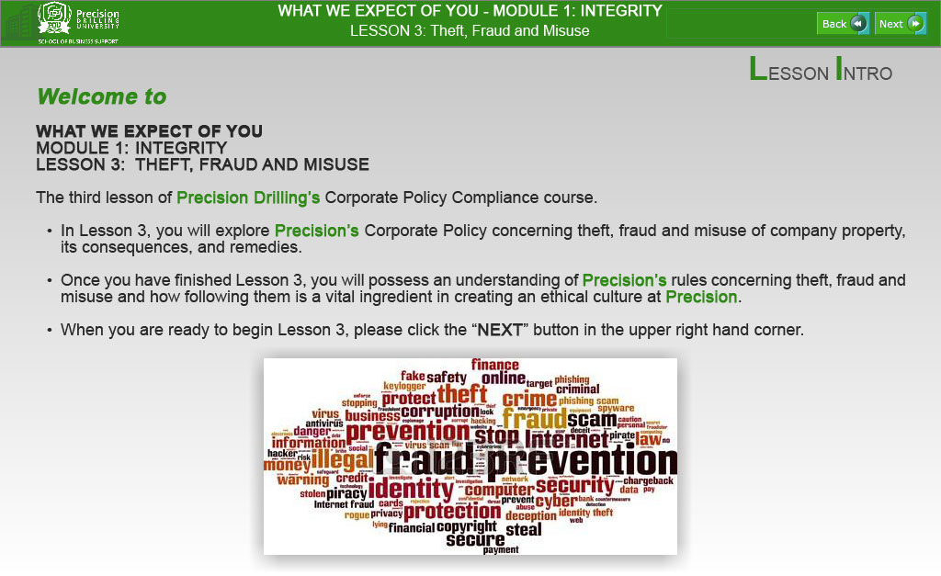
Text Captions
LESSON INTRO

Welcome to

WHAT WE EXPECT OF YOU
MODULE 1: INTEGRITY
LESSON 3: THEFT, FRAUD AND MISUSE

The third lesson of Precision Drilling’s Corporate Policy Compliance course.

- In Lesson 3, you will explore Precision’s Corporate Policy concerning theft, fraud and misuse of company property, its consequences, and remedies.

- Once you have finished Lesson 3, you will possess an understanding of Precision’s rules concerning theft, fraud and misuse and how following them is a vital ingredient in creating an ethical culture at Precision.

- When you are ready to begin Lesson 3, please click the “NEXT” button in the upper right hand corner.

Slide 3 - Slide 3
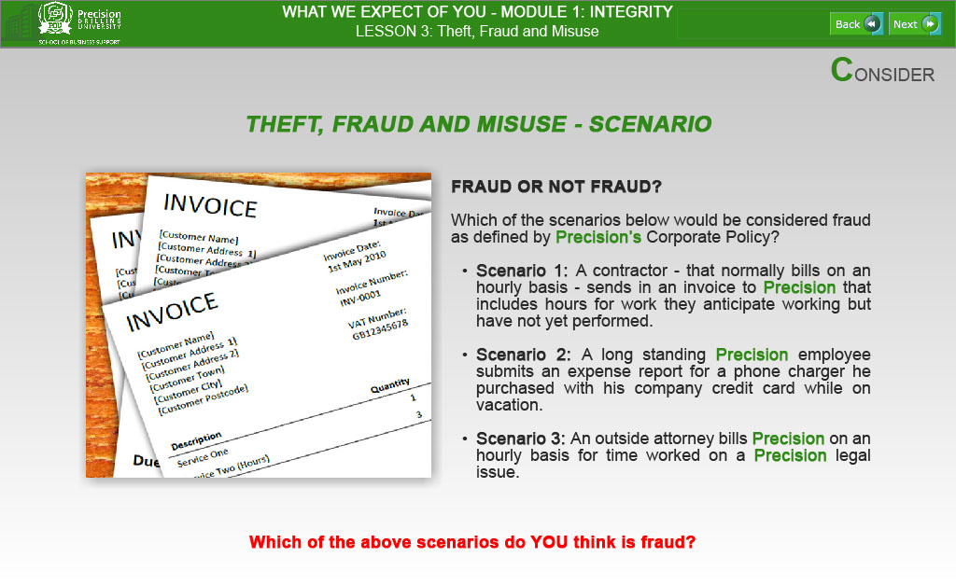
Text Captions
CONSIDER

THEFT, FRAUD AND MISUSE - SCENARIO

FRAUD OR NOT FRAUD?

Which of the scenarios below would be considered fraud as defined by Precision’s Corporate Policy?

- Scenario 1: A contractor - that normally bills on an hourly basis - sends in an invoice to Precision that includes hours for work they anticipate working but have not yet performed.

- Scenario 2: A long standing Precision employee submits an expense report for a phone charger he purchased with his company credit card while on vacation.

- Scenario 3: An outside attorney bills Precision on an hourly basis for time worked on a Precision legal issue.

Which of the above scenarios do YOU think is fraud?

Slide 4 - Slide 4
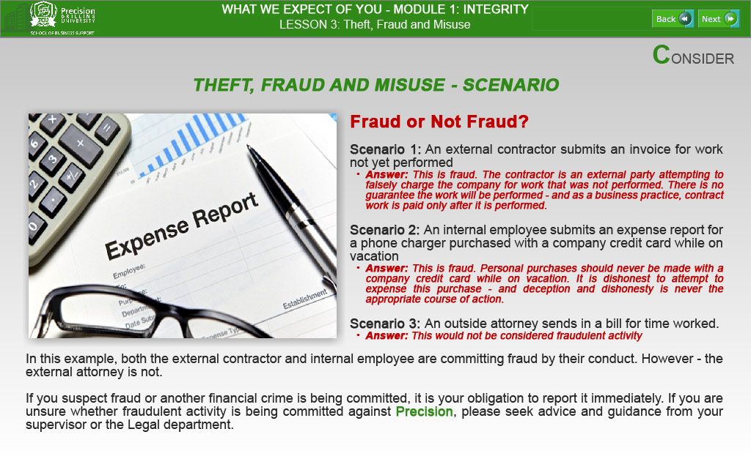
Text Captions
CONSIDER

THEFT, FRAUD AND MISUSE - SCENARIO
Fraud or Not Fraud?

Scenario 1: An external contractor submits an invoice for work not yet performed
- Answer: This is fraud. The contractor is an external party attempting to falsely charge the company for work that was not performed. There is no guarantee the work will be performed - and as a business practice, contract work is paid only after it is performed.

Scenario 2: An internal employee submits an expense report for a phone charger purchased with a company credit card while on vacation
- Answer: This is fraud. Personal purchases should never be made with a company credit card while on vacation. It is dishonest to attempt to expense this purchase - and deception and dishonesty is never the appropriate course of action.

Scenario 3: An outside attorney sends in a bill for time worked.
- Answer: This would not be considered fraudulent activity

In this example, both the external contractor and internal employee are committing fraud by their conduct. However - the external attorney is not.

If you suspect fraud or another financial crime is being committed, it is your obligation to report it immediately. If you are unsure whether fraudulent activity is being committed against Precision, please seek advice and guidance from your supervisor or the Legal department.
Slide 5 - Slide 5
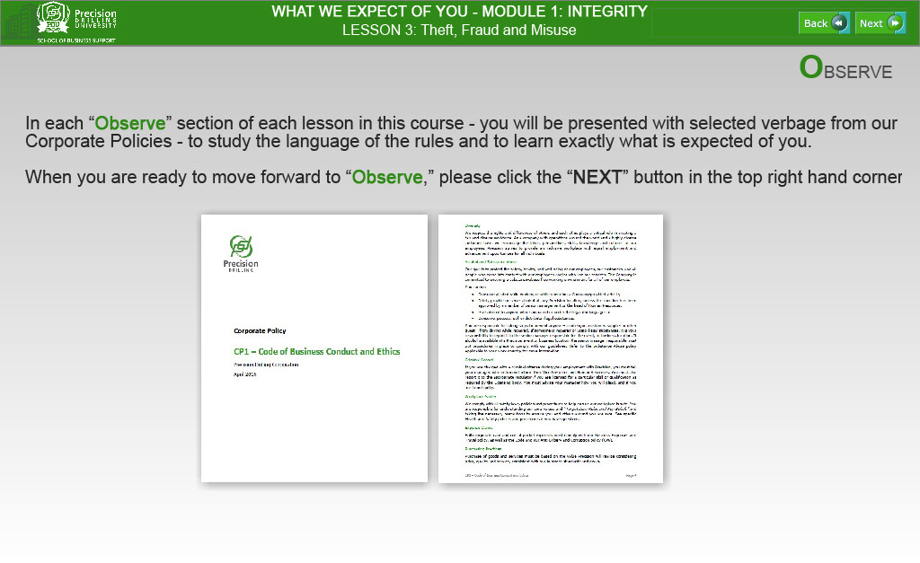
Text Captions
OBSERVE

In each “Observe” section of each lesson in this course - you will be presented with selected verbage from our Corporate Policies - to study the language of the rules and to learn exactly what is expected of you.

When you are ready to move forward to “Observe,” please click the “NEXT” button in the top right hand corner.

WHAT WE EXPECT OF YOU - MODULE 1: INTEGRITY

LESSON 3: Theft, Fraud and Misuse

Slide 6 - Slide 6
Text Captions
OBSERVE

Please click on each tab to view definitions for “Fraud,” Theft” and “Misuse.”

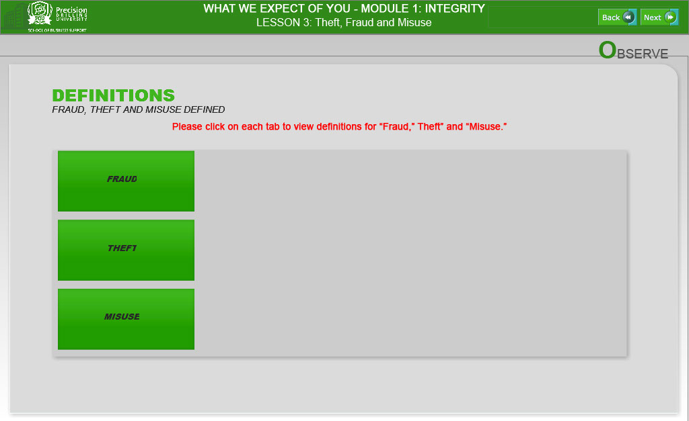

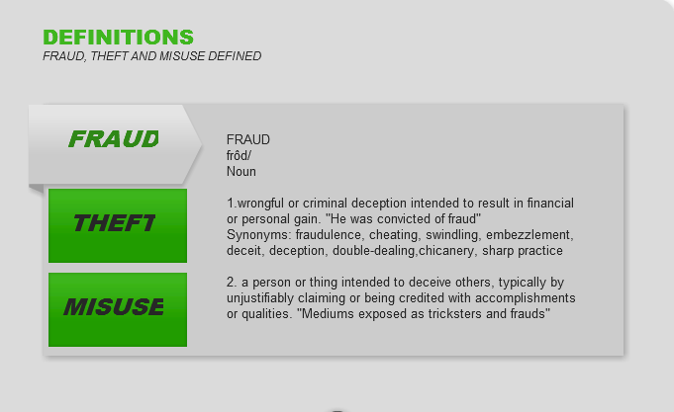
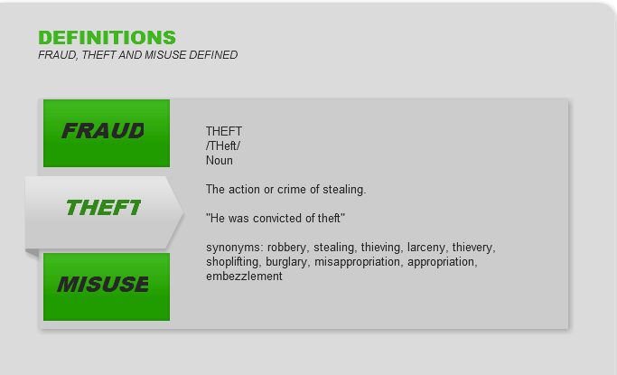

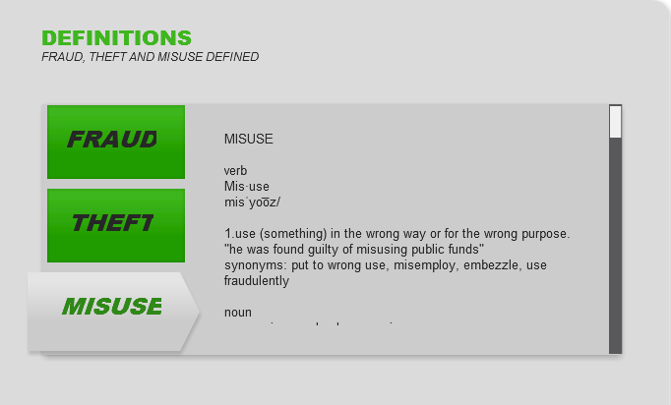

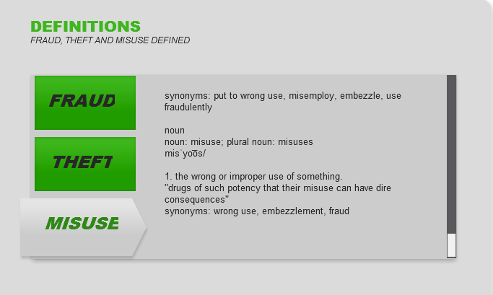
Slide 7 - Slide 7
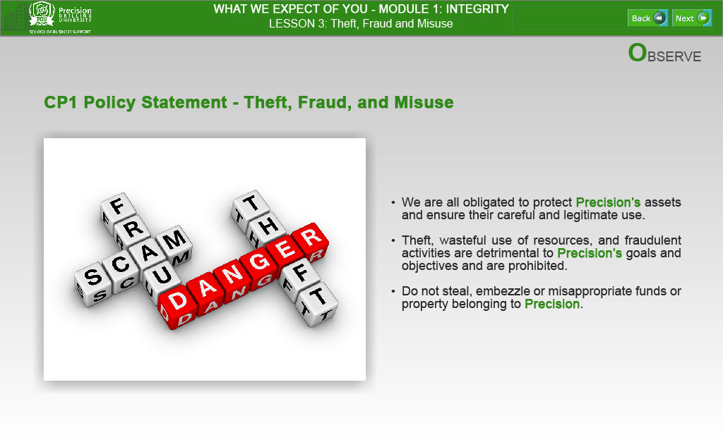
Text Captions
OBSERVE

CP1 Policy Statement - Theft, Fraud, and Misuse

- We are all obligated to protect Precision’s assets and ensure their careful and legitimate use.

- Theft, wasteful use of resources, and fraudulent activities are detrimental to Precision’s goals and objectives and are prohibited.

- Do not steal, embezzle or misappropriate funds or property belonging to Precision.

LESSON 3: Theft, Fraud and Misuse

Slide 8 - Slide 8
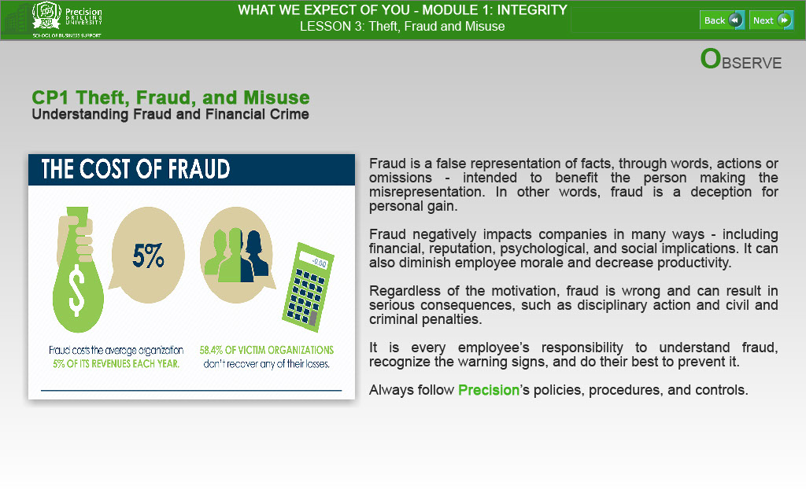
Text Captions
OBSERVE

CP1 Theft, Fraud, and Misuse
Understanding Fraud and Financial Crime

Fraud is a false representation of facts, through words, actions or omissions - intended to benefit the person making the misrepresentation. In other words, fraud is a deception for personal gain.

Fraud negatively impacts companies in many ways - including financial, reputation, psychological, and social implications. It can also diminish employee morale and decrease productivity.

Regardless of the motivation, fraud is wrong and can result in serious consequences, such as disciplinary action and civil and criminal penalties.

It is every employee’s responsibility to understand fraud, recognize the warning signs, and do their best to prevent it.

Always follow Precision’s policies, procedures, and controls.

Slide 9 - Slide 9
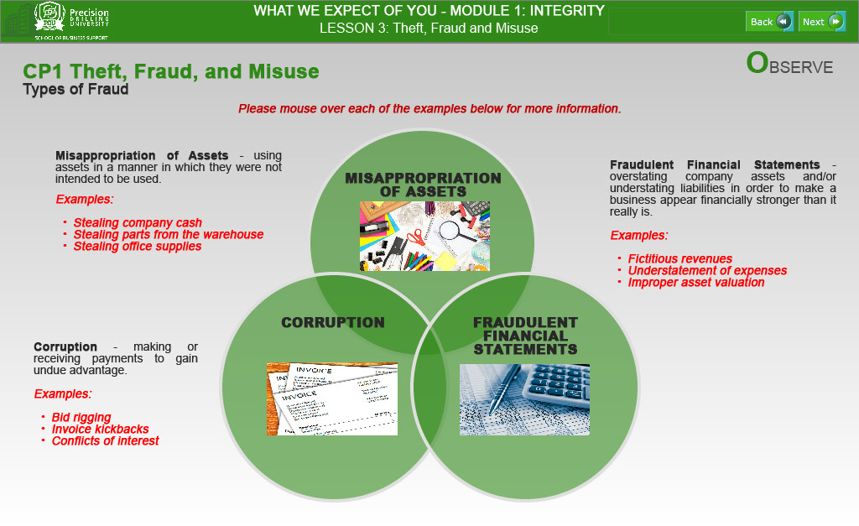
Text Captions
OBSERVE

CP1 Theft, Fraud, and Misuse
Types of Fraud

EACH MOUSE OVER BULLET TEXT FOR EACH PICTURE ABOVE IS INITIALLY HIDDEN

Misappropriation of Assets - using assets in a manner in which they were not intended to be used.
Examples:
- Stealing company cash
- Stealing parts from the warehouse
- Stealing office supplies

Corruption - making or receiving payments to gain undue advantage.
Examples:
- Bid rigging
- Invoice kickbacks
- Conflicts of interest

Fraudulent Financial Statements - overstating company assets and/or understating liabilities in order to make a business appear financially stronger than it really is.
Examples:
- Fictitious revenues
- Understatement of expenses
- Improper asset valuation
Slide 10 - Slide 10
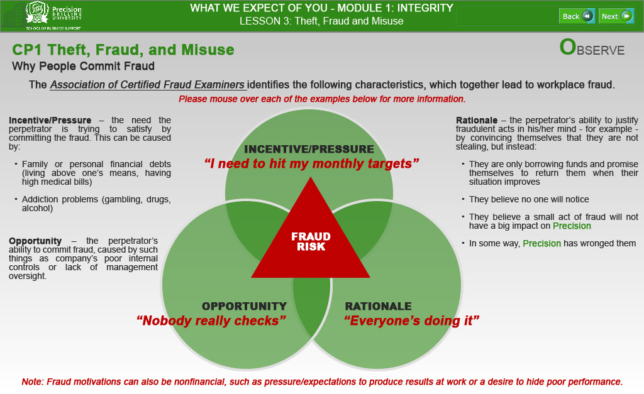
Text Captions
OBSERVE

CP1 Theft, Fraud, and Misuse
Why People Commit Fraud

The Association of Certified Fraud Examiners identifies the following characteristics, which together lead to workplace fraud.

INCENTIVE/PRESSURE
“I need to hit my monthly targets”

OPPORTUNITY
“Nobody really checks”

RATIONALE
“Everyone’s doing it”

FRAUD
RISK

EACH MOUSE OVER BULLET TEXT FOR EACH PICTURE ABOVE IS INITIALLY HIDDEN

Incentive/Pressure – the need the perpetrator is trying to satisfy by committing the fraud. This can be caused by:

- Family or personal financial debts (living above one’s means, having high medical bills)
- Addiction problems (gambling, drugs, alcohol)

Opportunity – the perpetrator’s ability to commit fraud, caused by such things as company’s poor internal controls or lack of management oversight.

Rationale – the perpetrator’s ability to justify fraudulent acts in his/her mind - for example - by convincing themselves that they are not stealing, but instead:

- They are only borrowing funds and promise themselves to return them when their situation improves
- They believe no one will notice
- They believe a small act of fraud will not have a big impact on Precision
- In some way, Precision has wronged them

Note: Fraud motivations can also be nonfinancial, such as pressure/expectations to produce results at work or a desire to hide poor performance.

Slide 11 - Slide 11
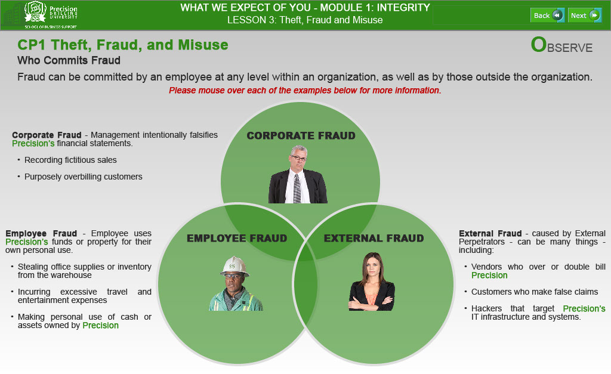
Text Captions
OBSERVE

CP1 Theft, Fraud, and Misuse
Who Commits Fraud

Fraud can be committed by an employee at any level within an organization, as well as by those outside the organization.

EACH MOUSE OVER BULLET TEXT FOR EACH PICTURE ABOVE IS INITIALLY HIDDEN

Employee Fraud - Employee uses Precision’s funds or property for their own personal use.
- Stealing office supplies or inventory from the warehouse
- Incurring excessive travel and entertainment expenses
- Making personal use of cash or assets owned by Precision

Corporate Fraud - Management intentionally falsifies Precision’s financial statements.
- Recording fictitious sales
- Purposely overbilling customers

External Fraud - caused by External Perpetrators - can be many things - including:
- Vendors who over or double bill Precision
- Customers who make false claims
- Hackers that target Precision’s IT infrastructure and systems.

Slide 12 - Slide 12
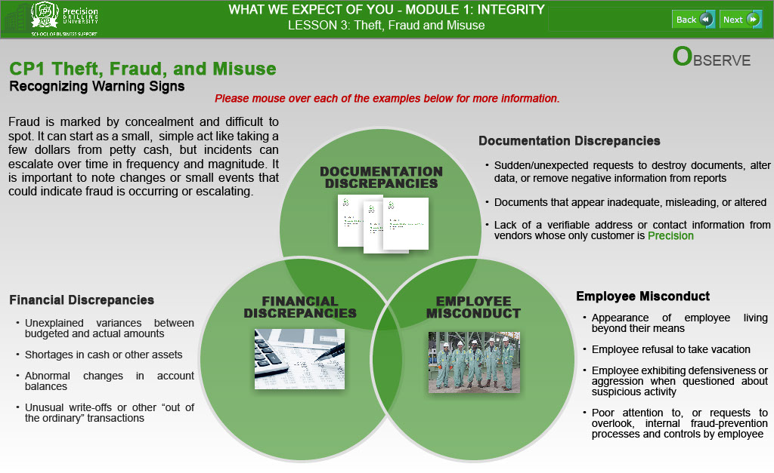
Text Captions
OBSERVE

CP1 Theft, Fraud, and Misuse
Recognizing Warning Signs

Fraud is marked by concealment and difficult to spot. It can start as a small, simple act like taking a few dollars from petty cash, but incidents can escalate over time in frequency and magnitude. It is important to note changes or small events that could indicate fraud is occurring or escalating.

EACH MOUSE OVER BULLET TEXT FOR EACH PICTURE ABOVE IS INITIALLY HIDDEN

Employee Misconduct
- Appearance of employee living beyond their means
- Employee refusal to take vacation
- Employee exhibiting defensiveness or aggression when questioned about suspicious activity
- Poor attention to, or requests to overlook, internal fraud-prevention processes and controls by employee

Documentation Discrepancies
- Sudden/unexpected requests to destroy documents, alter data, or remove negative information from reports
- Documents that appear inadequate, misleading, or altered
- Lack of a verifiable address or contact information from vendors whose only customer is Precision

Financial Discrepancies
- Unexplained variances between budgeted and actual amounts
- Shortages in cash or other assets
- Abnormal changes in account balances
- Unusual write-offs or other “out of the ordinary” transactions
Slide 13 - Slide 13
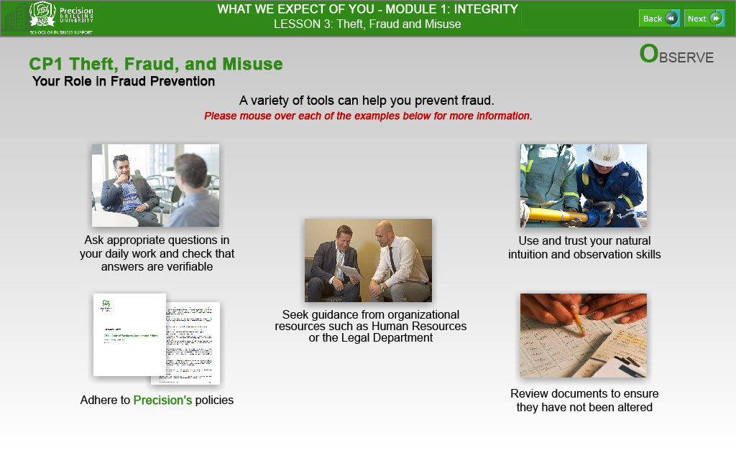
Text Captions
OBSERVE

CP1 Theft, Fraud, and Misuse
Your Role in Fraud Prevention

A variety of tools can help you prevent fraud.

Ask appropriate questions in your daily work and check that answers are verifiable

Adhere to Precision’s policies

Seek guidance from organizational resources such as Human Resources or the Legal Department

Use and trust your natural intuition and observation skills

Review documents to ensure they have not been altered

EACH MOUSE OVER BULLET TEXT FOR EACH PICTURE ABOVE IS INITIALLY HIDDEN

Slide 14 - Slide 14
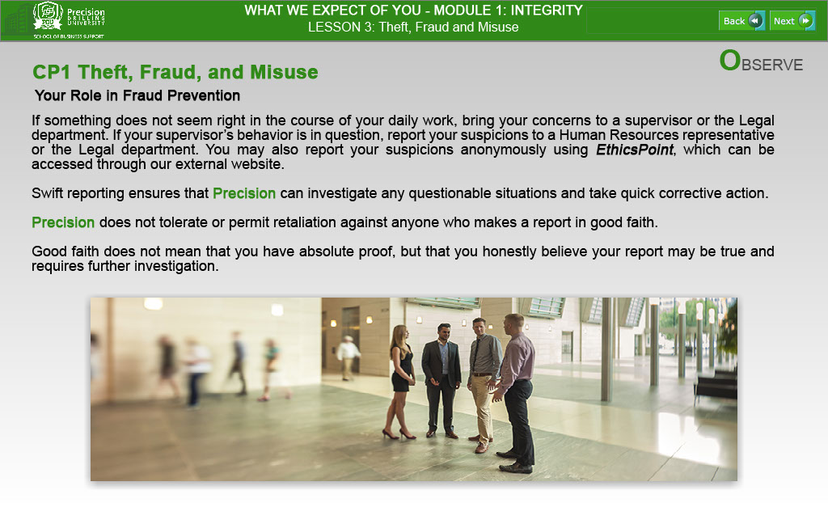
Text Captions
OBSERVE

CP1 Theft, Fraud, and Misuse
Your Role in Fraud Prevention

If something does not seem right in the course of your daily work, bring your concerns to a supervisor or the Legal department. If your supervisor’s behavior is in question, report your suspicions to a Human Resources representative or the Legal department. You may also report your suspicions anonymously using EthicsPoint, which can be accessed through our external website.

Swift reporting ensures that Precision can investigate any questionable situations and take quick corrective action.

Precision does not tolerate or permit retaliation against anyone who makes a report in good faith.

Good faith does not mean that you have absolute proof, but that you honestly believe your report may be true and requires further investigation.

LESSON 3: Theft, Fraud and Misuse

Slide 15 - Slide 15

Text Captions
DEVELOP

In the next section of Lesson 3, you will further explore “Theft, Fraud and Misuse” through interactive Learning Activities.

When you are ready to begin this “Develop” Section, please click the “NEXT” button.

WHAT WE EXPECT OF YOU - MODULE 1: INTEGRITY

LESSON 3: Theft, Fraud and Misuse

Slide 16 - Slide 16
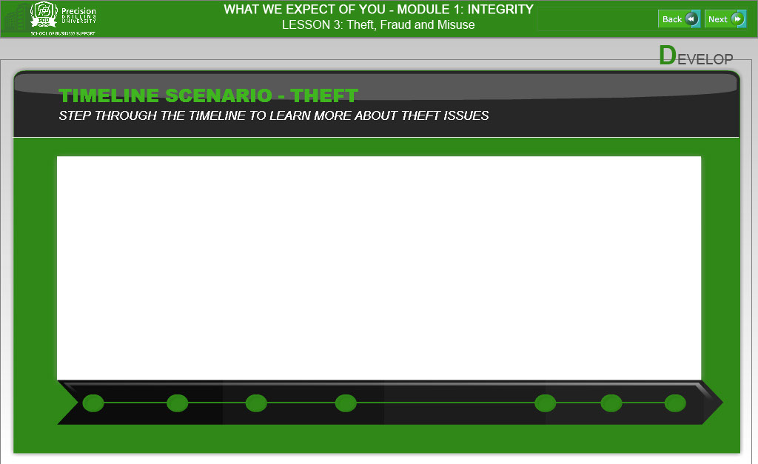

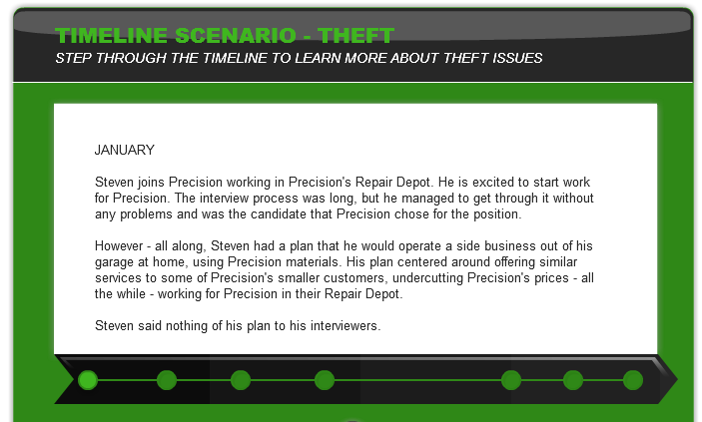
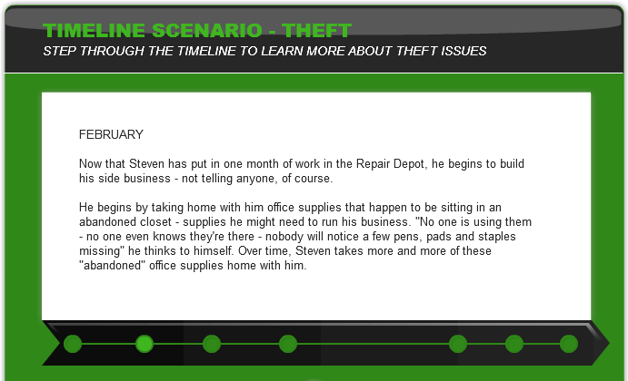

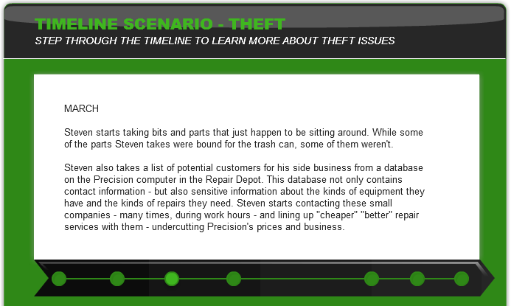
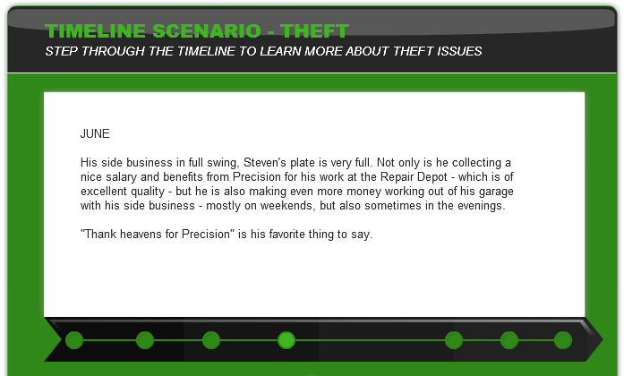

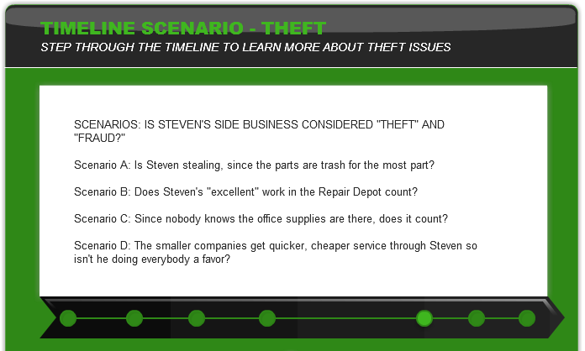
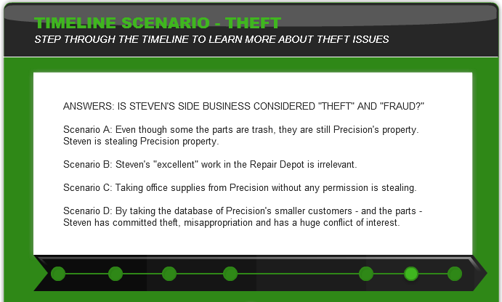

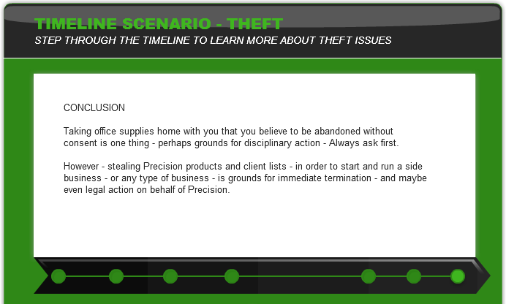

LESSON 3: Theft, Fraud and Misuse

Slide 17 - Slide 17
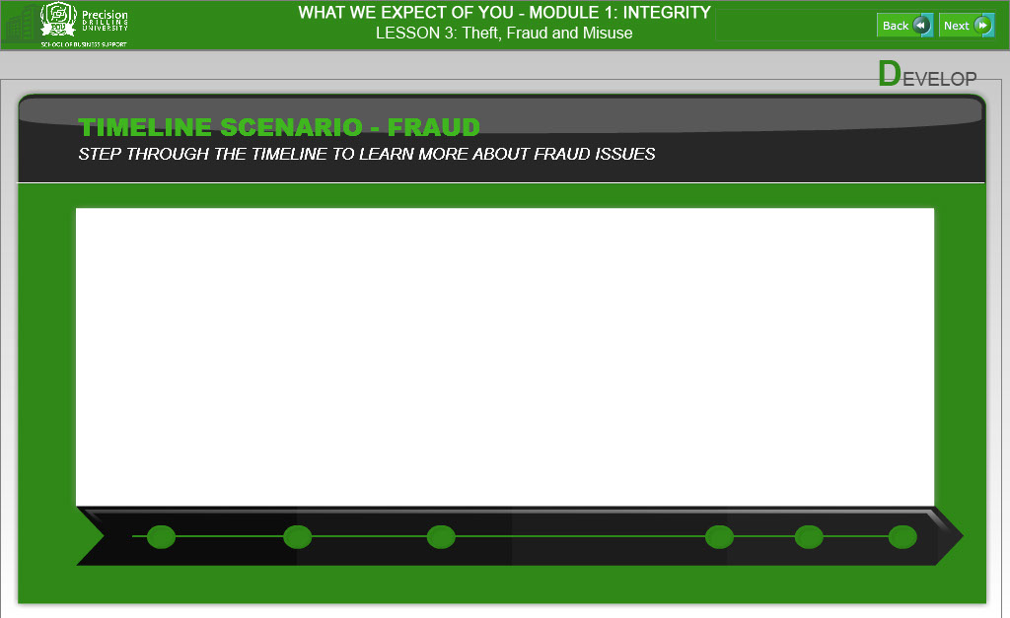

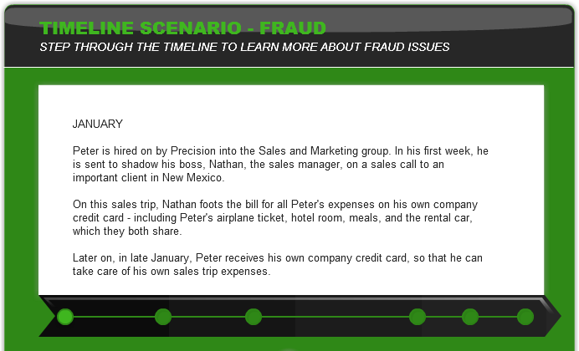
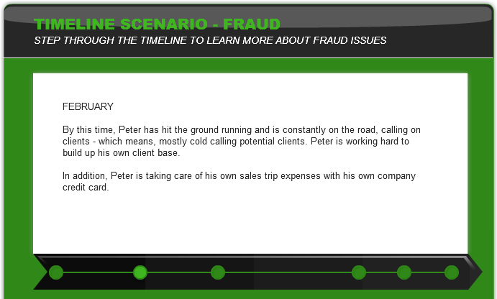

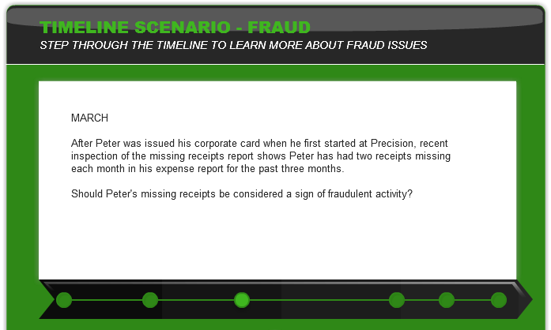
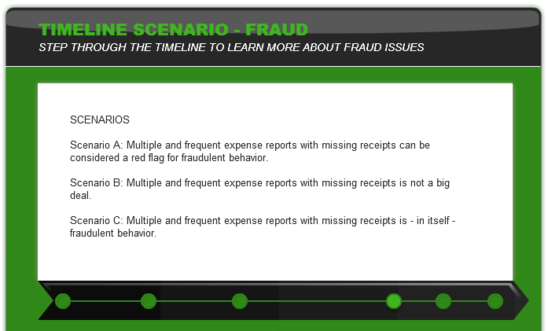

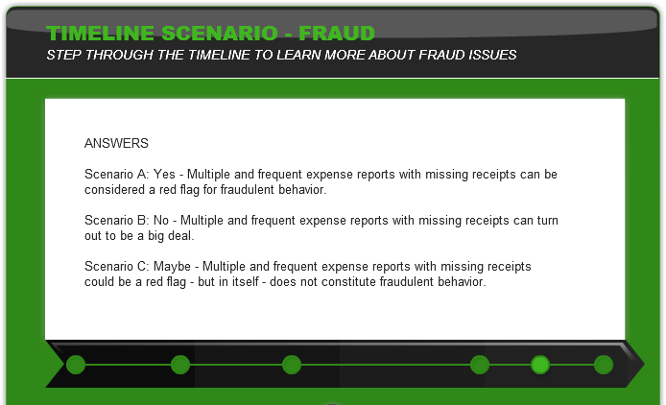
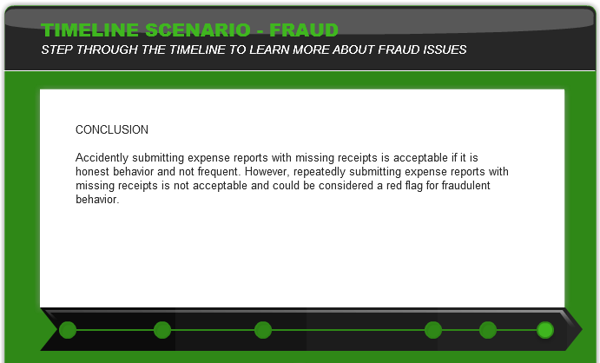
WHAT WE EXPECT OF YOU - MODULE 1: INTEGRITY

LESSON 3: Theft, Fraud and Misuse

Slide 18 - Slide 18
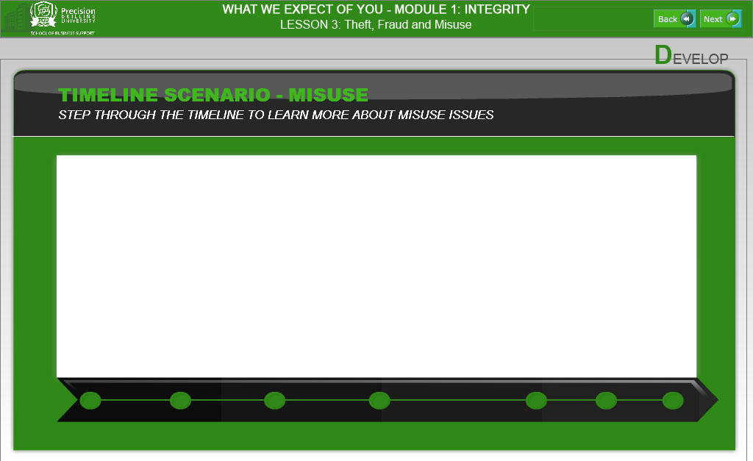

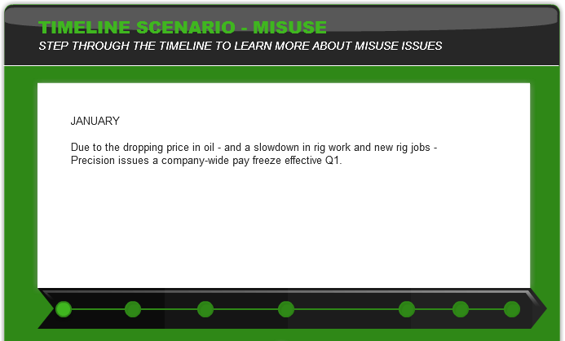
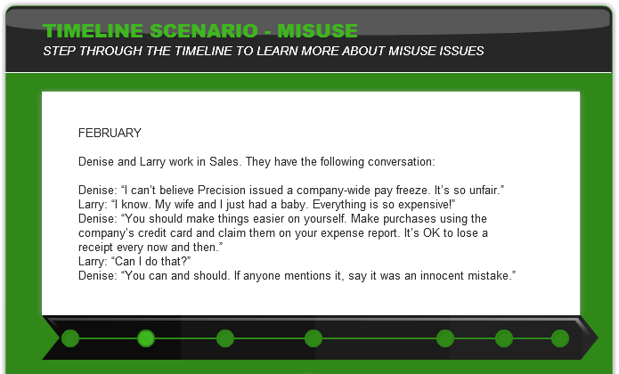

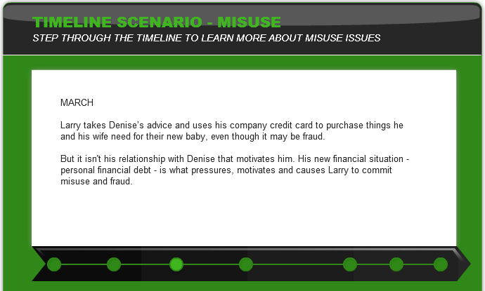
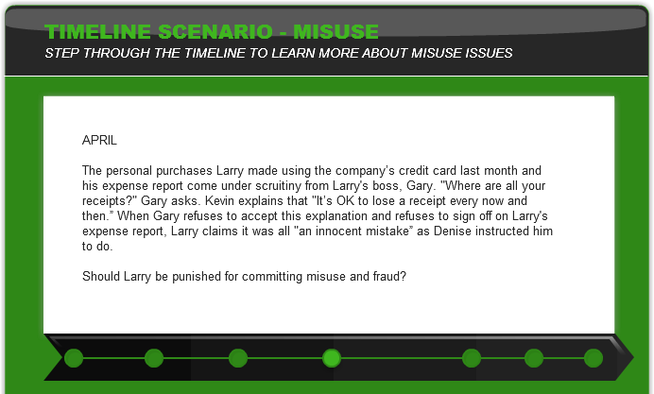

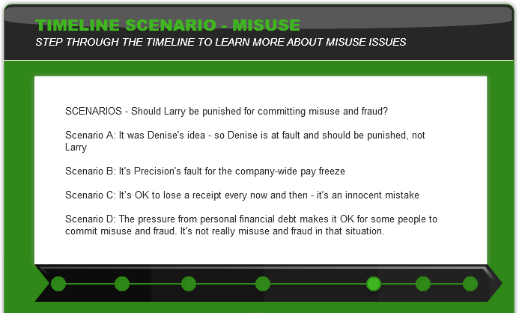
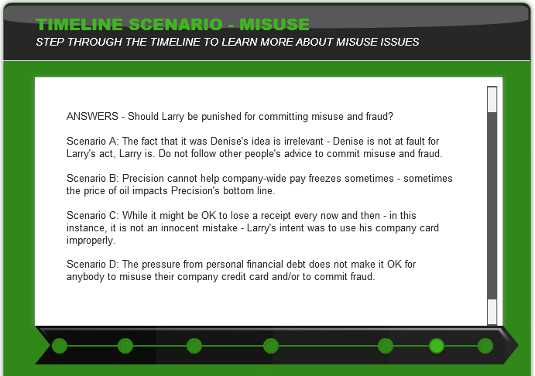

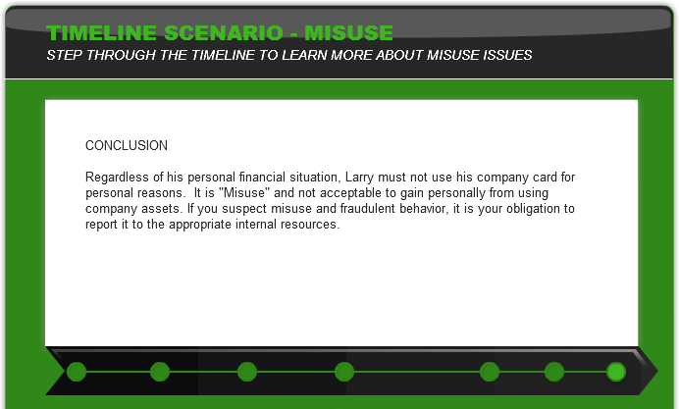

WHAT WE EXPECT OF YOU - MODULE 1: INTEGRITY

Slide 19 - Slide 19
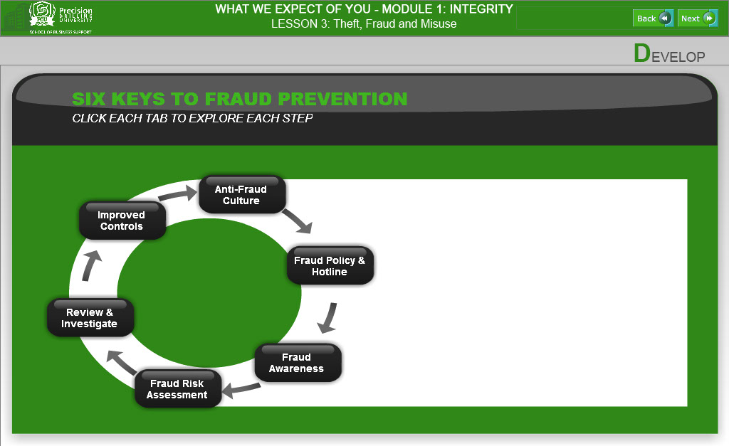
Text Captions
DEVELOP

- ANTIFRAUD CULTURE BUTTON:
• LEAD BY EXAMPLE
Responsibility of Directors and Officers
Behave ethically and openly communicate expectations to employees
Treat all employees equally
Zero tolerance

• CREATE POSITIVE WORKPLACE ENVIRONMENT
Focus on employee morale
Empower employees
Communicate

• HIRE/PROMOTE APPROPRIATE EMPLOYEES
Conduct background investigations before hiring or promoting
Check candidate's education, employment history, references
Continuous and objective evaluation of compliance with entity values
Violations addressed immediately

• CODE OF CONDUCT
Formalized and founded on integrity
Defines acceptable employee behavior
Communicated to all employees
All employees are held accountable for compliance

• DISCIPLINE
Sends a strong message throughout the entity.
ShouId be appropriate and consistent
Consequences of committing fraud clearly communicated throughout the entity

• OVERSIGHT PROCESS
Audit Committee or Board of Directors
• Evaluate management's " tone at the top", identification of fraud risks and implementation of anti-fraud controls
• Ensure that management implements anti-fraud measures
• Consider the potential for management override of controls

Management
• Directs, implements and monitors anti-fraud controls
• Sets the ethical tone
• Trains employees

Internal Auditor
• Identifies fraud indicators
• Assesses fraud risks
• Evaluates anti-fraud controls
• Recommends actions to mitigate risks
• Investigates potential frauds

- FRAUD POLICY & HOTLINE BUTTON:

• FRAUD POLICY
• Reviewed and updated regularly.
• Signed off and agreed to by the CEO and Board Chair.
• See the ACFE for an example Fraud Policy:
• http://www.acfe.com/uploadedFiIes/ACFEWebsite/Content/documents/SampleFraudPolicy.pdf

• HOTLINE
• Enable employees, vendors, customers and others to communicate concerns about known or suspected wrongdoing.
• Telephone, email, internet.
• Anonymous.
• Adequately publicized.
• Internal or External.
• Complaint monitoring and investigation/resolution.

- FRAUD AWARENESS BUTTON:
• All new employees should be trained at time of hiring on the Code of Conduct and Fraud Policy.
• Training should include:
- Employee duty to communicate certain matters
- A list of the types of matters to be communicated along with examples how to communicate those matters
- Affirmation from senior management regarding employee expectations and communication responsibilities
• Refresher fraud training periodically

- FRAUD RISK AWARENESS BUTTON:
• Conduct an annual fraud risk assessment.
- Assists management in systematically identifying where and how fraud may occur and who may be in a position to commit fraud
- Focus on fraud schemes and scenarios to determine the presence of internal controls and whether or not the controls can be circumvented.

• General steps:
- Identify areas and processes to assess
- Identify pot ential fraud schemes in each area/process
- Assess likelihood and significant of each scheme
- Map existing anti-fraud controls to potential fraud schemes
- Test operating effectiveness of antifraud controls
- Identify any control gaps and/or deficiencies= Residual risks
- Document and report on the fraud risk assessment

• Mitigate Fraud Risks
- Make changes to activities and/or processes = transfer or eliminate the risks Improve anti-fraud controls

• Monitor Fraud Risks
- Develop data analytics for management to use to monitor fraud risks
- Utilize Internal Audit to conduct audits of risk areas.

- REVIEW & INVESTIGATE BUTTON:
• All concerns/suspicions of wrongdoing should be reviewed and determination made whether a fraud investigation is warranted.

• Develop a policy for fraud reviews and investigations that specifies:
- Who is responsible for the review/investigation
- Roles of Legal Counsel, Human Resources, Internal Audit, others
- Process for conducting the review/ investigation
- Documentation requirements
- Reporting requirements
- When to involve law enforcement

• Gather sufficient information and perform procedures necessary to determine:
- Whether fraud has occurred
- Loss or exposure associated with the fraud
- Who was involved and how it happened

• Must prepare, document and preserve evidence sufficient for potential legal proceedings.

• Include experts = Certified Fraud Examiner (CFE)

- IMPROVED CONTROLS BUTTON:
• Use lessons learned from any fraud reviews or investigations to improve anti-fraud controls.
• All fraud review and investigations should include a report to management with recommendations for control improvement

Slide 20 - Slide 20

Text Captions
EXAM

In the final “Exam” section of Lesson 3, you will be asked some simple questions as Knowledge Checks to showcase your mastery of Lesson 3 course material.

When you are ready to take this short, ungraded quiz, please click the “NEXT” button.

WHAT WE EXPECT OF YOU - MODULE 1: INTEGRITY

LESSON 3: Theft, Fraud and Misuse

Slide 21 - Slide 21
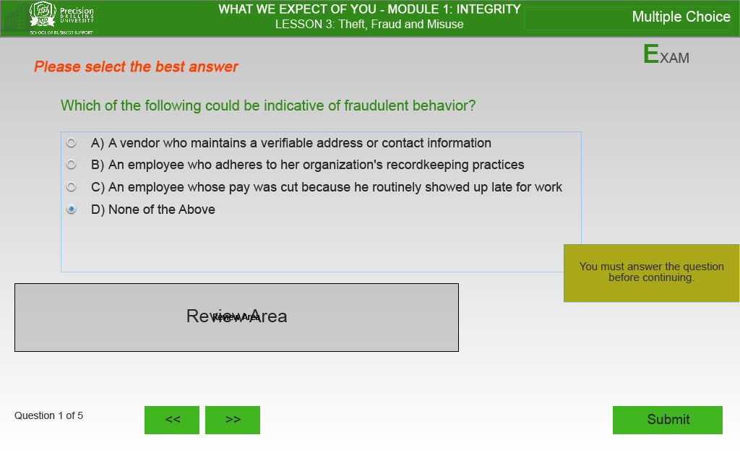
Text Captions
EXAM

Please select the best answer

Which of the following could be indicative of fraudulent behavior?

A) A vendor who maintains a verifiable address or contact information
B) An employee who adheres to her organization's recordkeeping practices
C) An employee whose pay was cut because he routinely showed up late for work
D) None of the Above

Question 1 of 5

Slide 22 - Slide 22
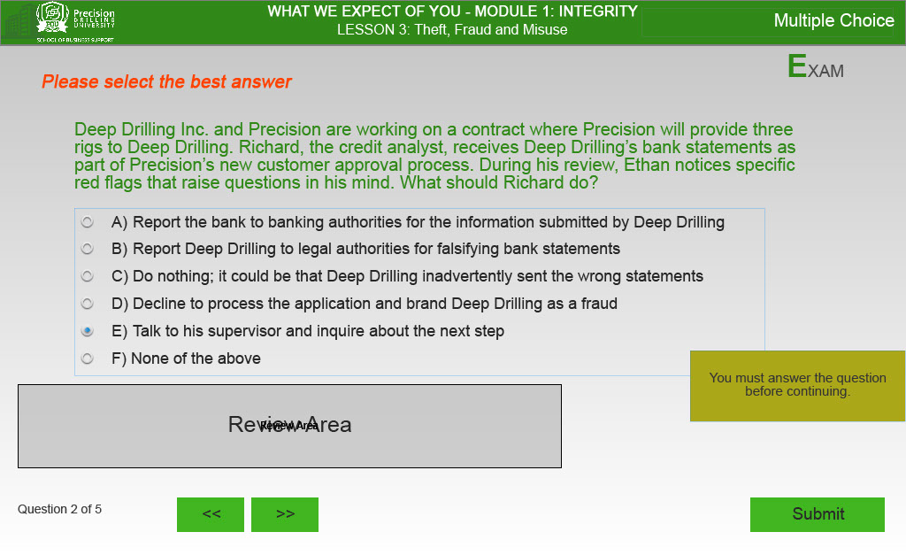
Text Captions
EXAM

Please select the best answer

Deep Drilling Inc. and Precision are working on a contract where Precision will provide three rigs to Deep Drilling. Richard, the credit analyst, receives Deep Drilling’s bank statements as part of Precision’s new customer approval process. During his review, Ethan notices specific red flags that raise questions in his mind. What should Richard do?

A) Report the bank to banking authorities for the information submitted by Deep Drilling
B) Report Deep Drilling to legal authorities for falsifying bank statements
C) Do nothing; it could be that Deep Drilling inadvertently sent the wrong statements
D) Decline to process the application and brand Deep Drilling as a fraud
E) Talk to his supervisor and inquire about the next step
F) None of the above

Question 2 of 5
Slide 23 - Slide 23
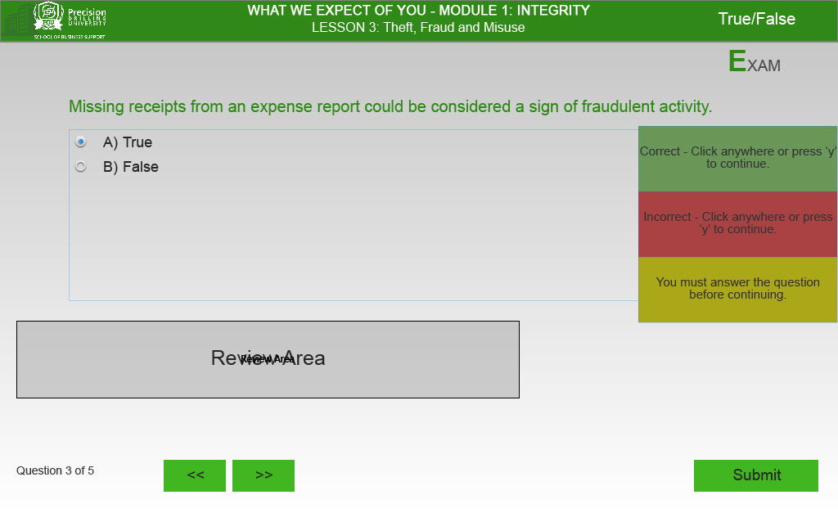
Text Captions
EXAM

Missing receipts from an expense report could be considered a sign of fraudulent activity.

A) True
B) False

Question 3 of 5

Slide 24 - Slide 24
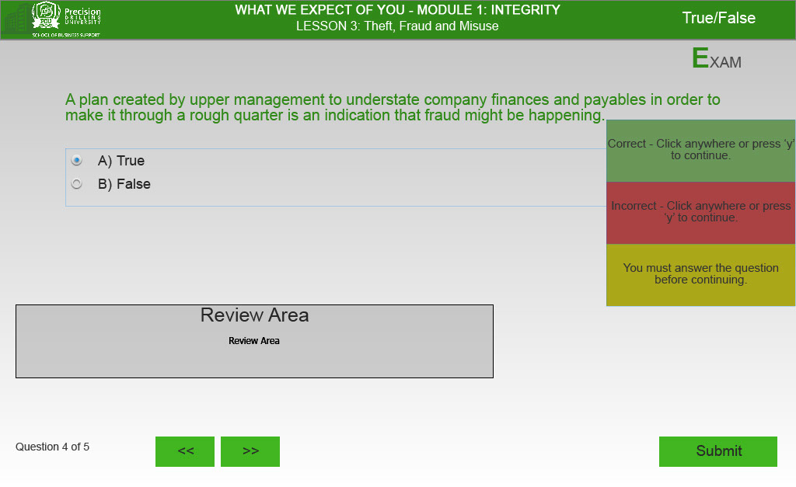
Text Captions
EXAM

A plan created by upper management to understate company finances and payables in order to make it through a rough quarter is an indication that fraud might be happening.

A) True
B) False

Question 4 of 5

Slide 25 - Slide 25
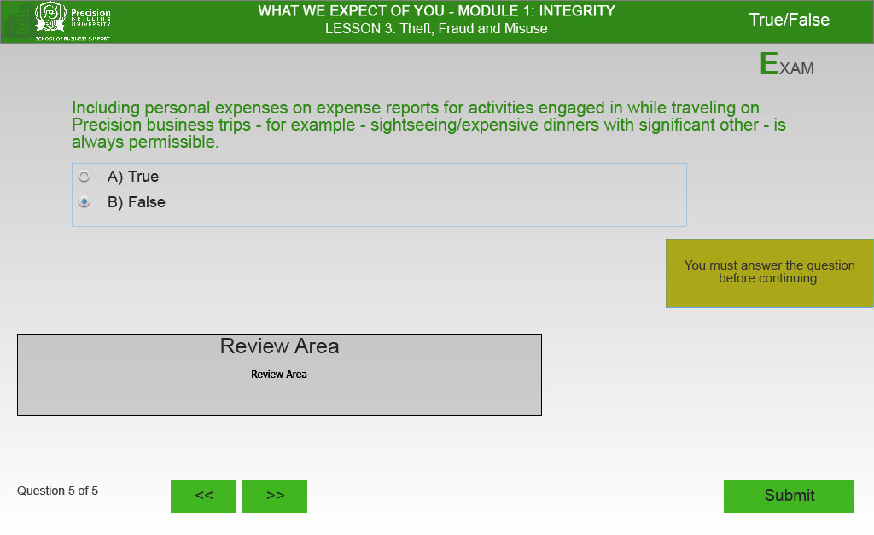
Text Captions
EXAM

Including personal expenses on expense reports for activities engaged in while traveling on Precision business trips - for example - sightseeing/expensive dinners with significant other - is always permissible.

A) True
B) False

Question 5 of 5

Slide 26 - Slide 26
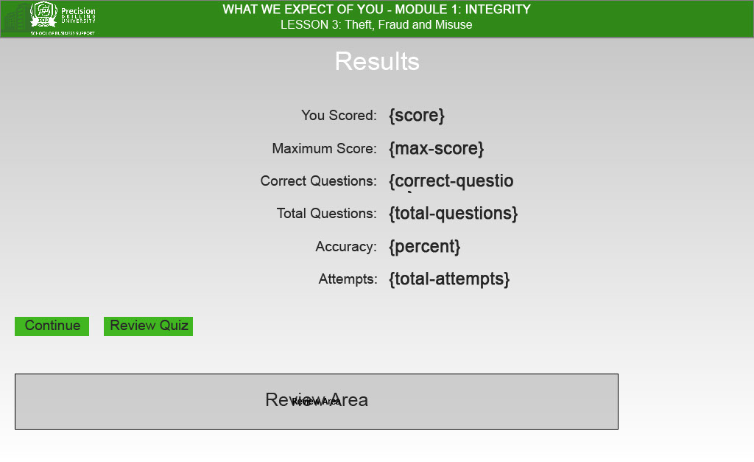
Slide 27 - Slide 27
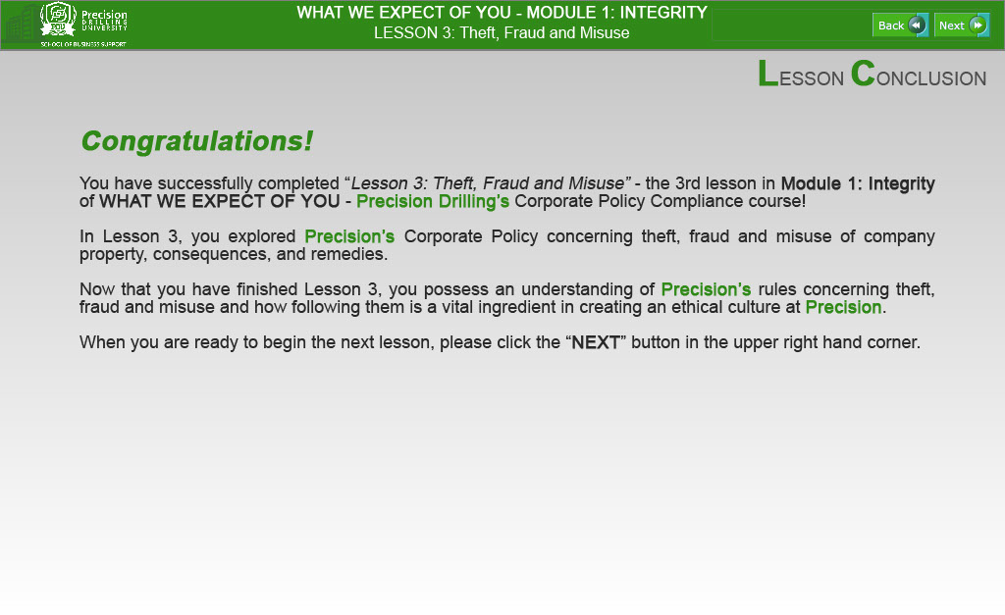
Text Captions
LESSON CONCLUSION

Congratulations!

You have successfully completed “Lesson 3: Theft, Fraud and Misuse” - the 3rd lesson in Module 1: Integrity of WHAT WE EXPECT OF YOU - Precision Drilling’s Corporate Policy Compliance course!

In Lesson 3, you explored Precision’s Corporate Policy concerning theft, fraud and misuse of company property, consequences, and remedies.

Now that you have finished Lesson 3, you possess an understanding of Precision’s rules concerning theft, fraud and misuse and how following them is a vital ingredient in creating an ethical culture at Precision.

When you are ready to begin the next lesson, please click the “NEXT” button in the upper right hand corner.
WHAT WE EXPECT OF YOU - MODULE 1: INTEGRITY

LESSON 3: Theft, Fraud and Misuse

