Slide 1 - Slide 1


Text Captions

WHAT WE EXPECT OF YOU
MODULE 1: INTEGRITY

LESSON 4: Trust

Slide 2 - Slide 2
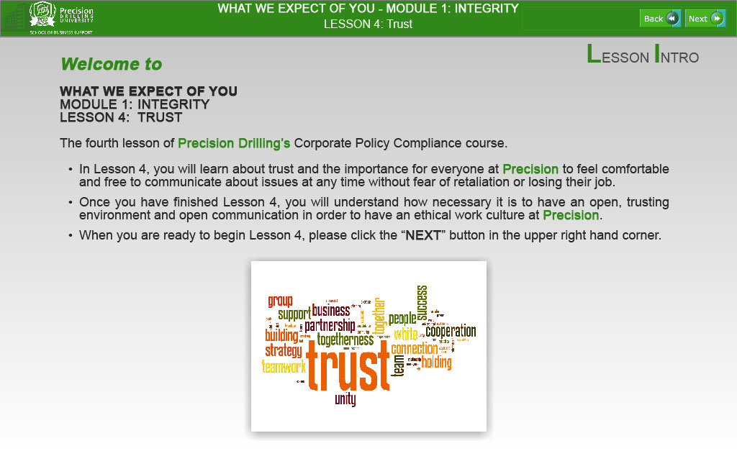
Text Captions
LESSON INTRO

Welcome to

WHAT WE EXPECT OF YOU
MODULE 1: INTEGRITY
LESSON 4: TRUST

The fourth lesson of Precision Drilling’s Corporate Policy Compliance course.

- In Lesson 4, you will learn about trust and the importance for everyone at Precision to feel comfortable and free to communicate about issues at any time without fear of retaliation or losing their job.

- Once you have finished Lesson 4, you will understand how necessary it is to have an open, trusting environment and open communication in order to have an ethical work culture at Precision.

- When you are ready to begin Lesson 4, please click the “NEXT” button in the upper right hand corner.

Slide 3 - Slide 3
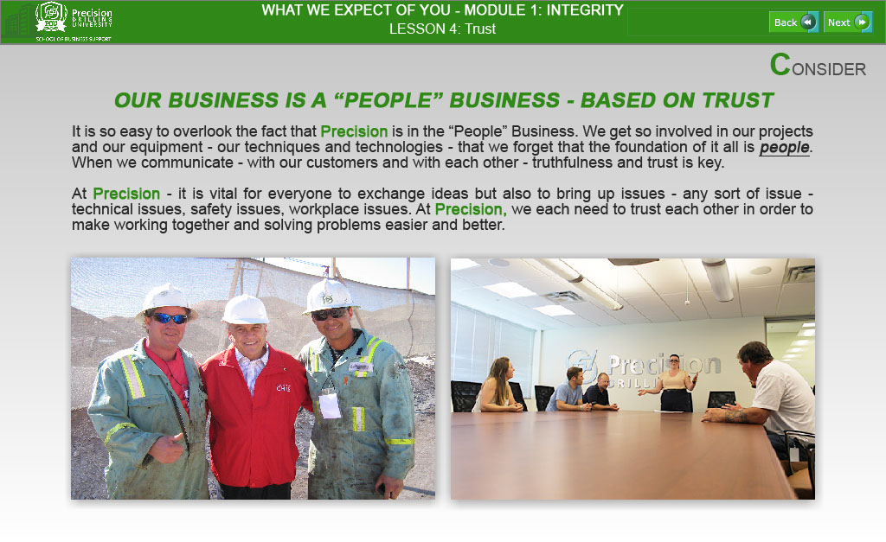
Text Captions
CONSIDER

OUR BUSINESS IS A “PEOPLE” BUSINESS - BASED ON TRUST

It is so easy to overlook the fact that Precision is in the “People” Business. We get so involved in our projects and our equipment - our techniques and technologies - that we forget that the foundation of it all is people. When we communicate - with our customers and with each other - truthfulness and trust is key.

At Precision - it is vital for everyone to exchange ideas but also to bring up issues - any sort of issue - technical issues, safety issues, workplace issues. At Precision, we each need to trust each other in order to make working together and solving problems easier and better.

WHAT WE EXPECT OF YOU - MODULE 1: INTEGRITY

LESSON 4: Trust

Slide 4 - Slide 4
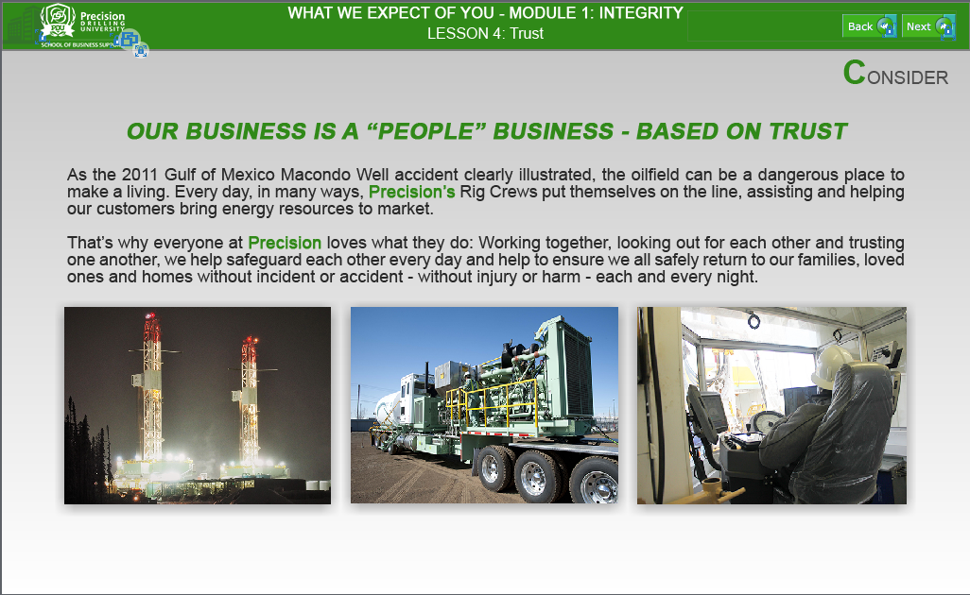
Text Captions
CONSIDER

OUR BUSINESS IS A “PEOPLE” BUSINESS - BASED ON TRUST

As the 2011 Gulf of Mexico Macondo Well accident clearly illustrated, the oilfield can be a dangerous place to make a living. Every day, in many ways, Precision’s Rig Crews put themselves on the line, assisting and helping our customers bring energy resources to market.

That’s why everyone at Precision loves what they do: Working together, looking out for each other and trusting one another, we help safeguard each other every day and help to ensure we all safely return to our families, loved ones and homes without incident or accident - without injury or harm - each and every night.

WHAT WE EXPECT OF YOU - MODULE 1: INTEGRITY

LESSON 4: Trust

Slide 5 - Slide 5
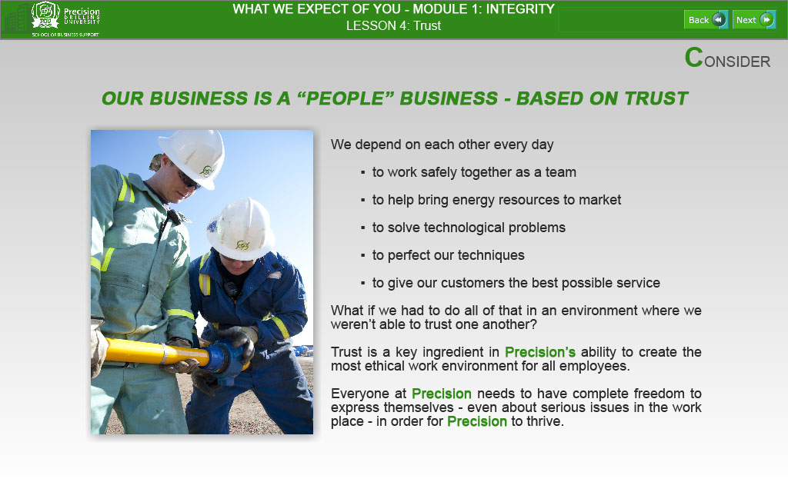
Text Captions
CONSIDER

OUR BUSINESS IS A “PEOPLE” BUSINESS - BASED ON TRUST

We depend on each other every day

- to work safely together as a team
- to help bring energy resources to market
- to solve technological problems
- to perfect our techniques
- to give our customers the best possible service

What if we had to do all of that in an environment where we weren’t able to trust one another?

Trust is a key ingredient in Precision’s ability to create the most ethical work environment for all employees.

Everyone at Precision needs to have complete freedom to express themselves - even about serious issues in the work place - in order for Precision to thrive.

Slide 6 - Slide 6
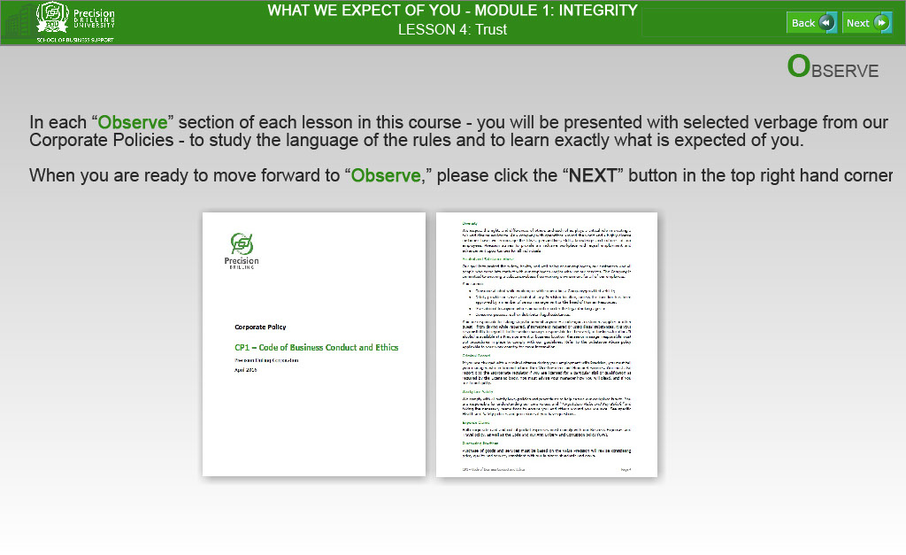
Text Captions
OBSERVE

In each “Observe” section of each lesson in this course - you will be presented with selected verbage from our Corporate Policies - to study the language of the rules and to learn exactly what is expected of you.

When you are ready to move forward to “Observe,” please click the “NEXT” button in the top right hand corner.

WHAT WE EXPECT OF YOU - MODULE 1: INTEGRITY

LESSON 4: Trust

Slide 7 - Slide 7
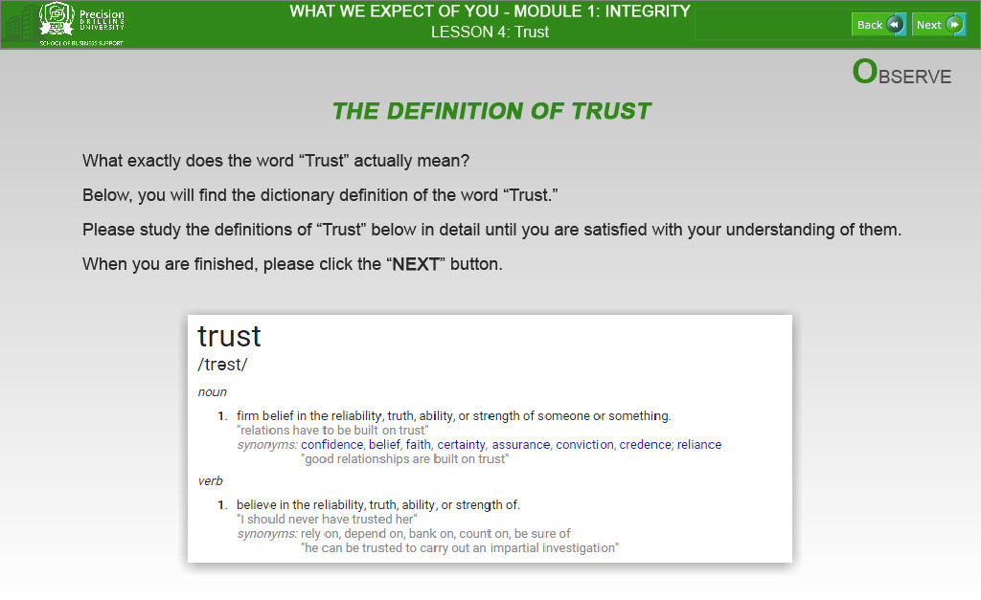
Text Captions
OBSERVE

THE DEFINITION OF TRUST

What exactly does the word “Trust” actually mean?

Below, you will find the dictionary definition of the word “Trust.”

Please study the definitions of “Trust” below in detail until you are satisfied with your understanding of them.

When you are finished, please click the “NEXT” button.

WHAT WE EXPECT OF YOU - MODULE 1: INTEGRITY

LESSON 4: Trust

Slide 8 - Slide 8
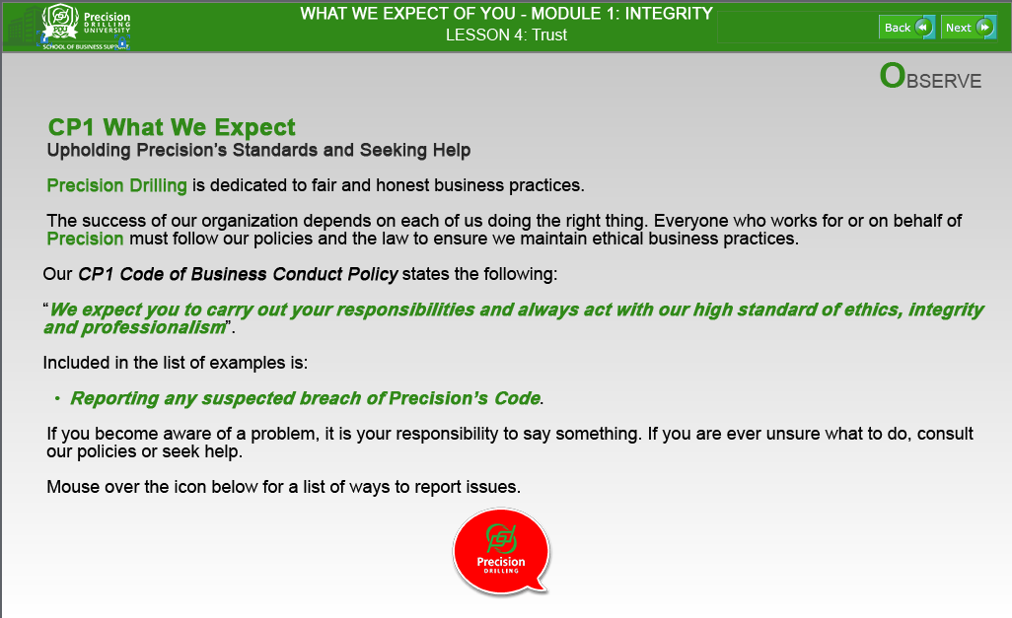

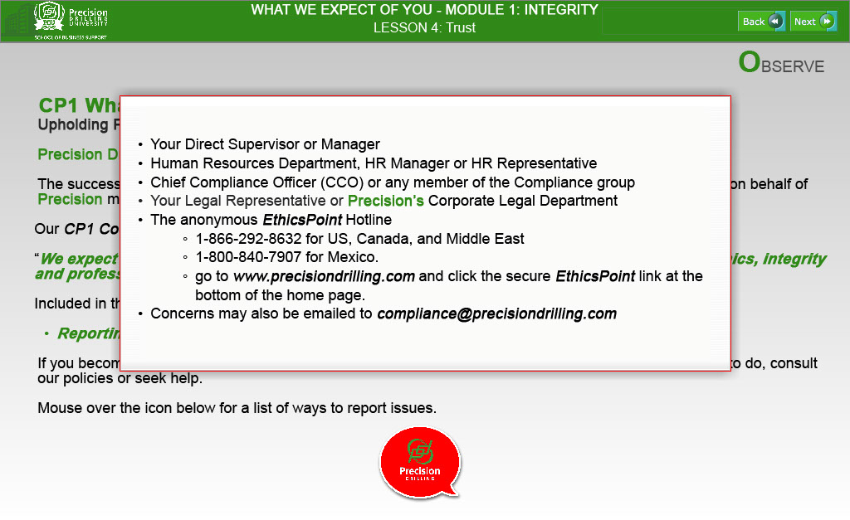

Text Captions
OBSERVE

CP1 What We Expect
Upholding Precision’s Standards and Seeking Help

Precision Drilling is dedicated to fair and honest business practices.

The success of our organization depends on each of us doing the right thing. Everyone who works for or on behalf of Precision must follow our policies and the law to ensure we maintain ethical business practices.

Our CP1 Code of Business Conduct Policy states the following:

“We expect you to carry out your responsibilities and always act with our high standard of ethics, integrity and professionalism”.

Included in the list of examples is:

- Reporting any suspected breach of Precision’s Code.

If you become aware of a problem, it is your responsibility to say something. If you are ever unsure what to do, consult our policies or seek help.

Mouse over the icon below for a list of ways to report issues

POPUP TEXT:
- Your Direct Supervisor or Manager
- Human Resources Department, HR Manager or HR Representative
- Chief Compliance Officer (CCO) or any member of the Compliance group
- Your Legal Representative or Precision’s Corporate Legal Department
- The anonymous EthicsPoint Hotline
- 1-866-292-8632 for US, Canada, and Middle East
- 1-800-840-7907 for Mexico.
- go to www.precisiondrilling.com and click the secure EthicsPoint link at the bottom of the home page.
- Concerns may also be emailed to compliance@precisiondrilling.com

Slide 9 - Slide 9
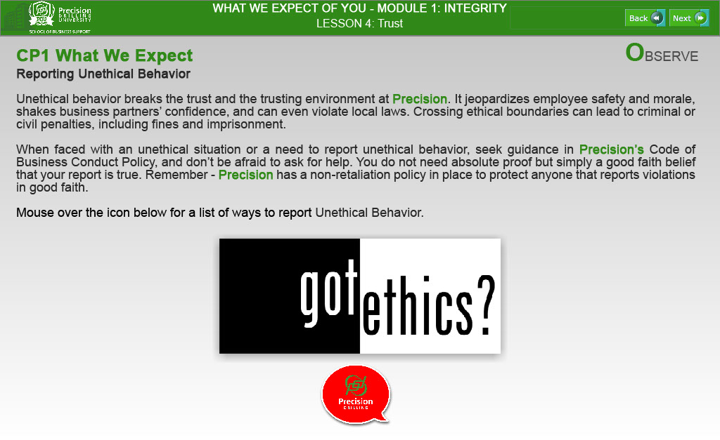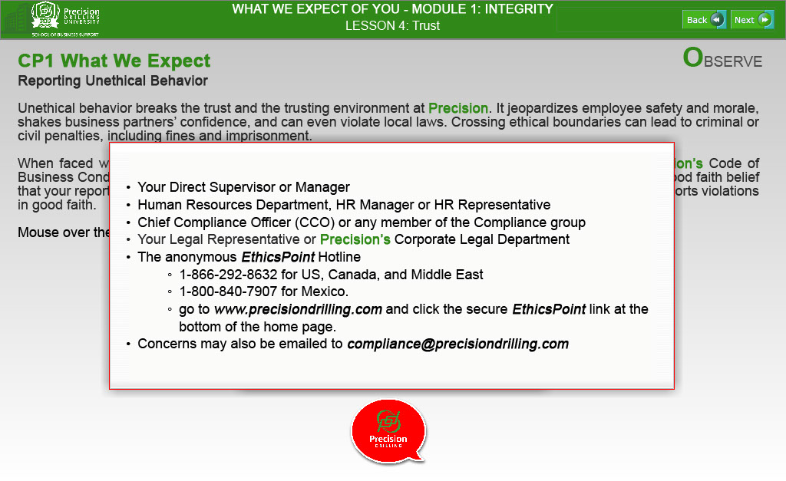

Text Captions
OBSERVE

CP1 What We Expect
Reporting Unethical Behavior

Unethical behavior breaks the trust and the trusting environment at Precision. It jeopardizes employee safety and morale, shakes business partners’ confidence, and can even violate local laws. Crossing ethical boundaries can lead to criminal or civil penalties, including fines and imprisonment.

When faced with an unethical situation or a need to report unethical behavior, seek guidance in Precision’s Code of Business Conduct Policy, and don’t be afraid to ask for help. You do not need absolute proof but simply a good faith belief that your report is true. Remember - Precision has a non-retaliation policy in place to protect anyone that reports violations in good faith.

Mouse over the icon below for a list of ways to report Unethical Behavior.

POPUP TEXT:
- Your Direct Supervisor or Manager
- Human Resources Department, HR Manager or HR Representative
- Chief Compliance Officer (CCO) or any member of the Compliance group
- Your Legal Representative or Precision’s Corporate Legal Department
- The anonymous EthicsPoint Hotline
- 1-866-292-8632 for US, Canada, and Middle East
- 1-800-840-7907 for Mexico.
- go to www.precisiondrilling.com and click the secure EthicsPoint link at the bottom of the home page.
- Concerns may also be emailed to compliance@precisiondrilling.com

Slide 10 - Slide 10
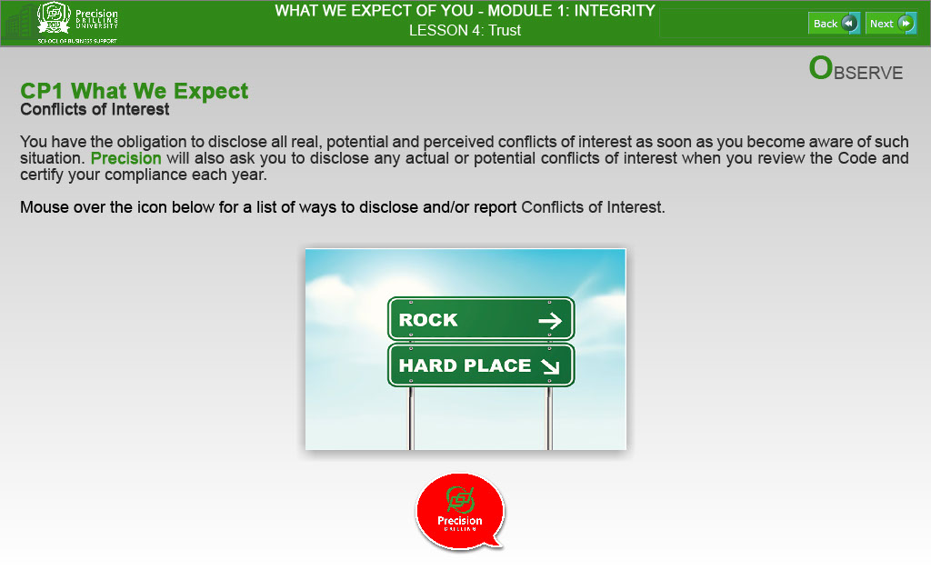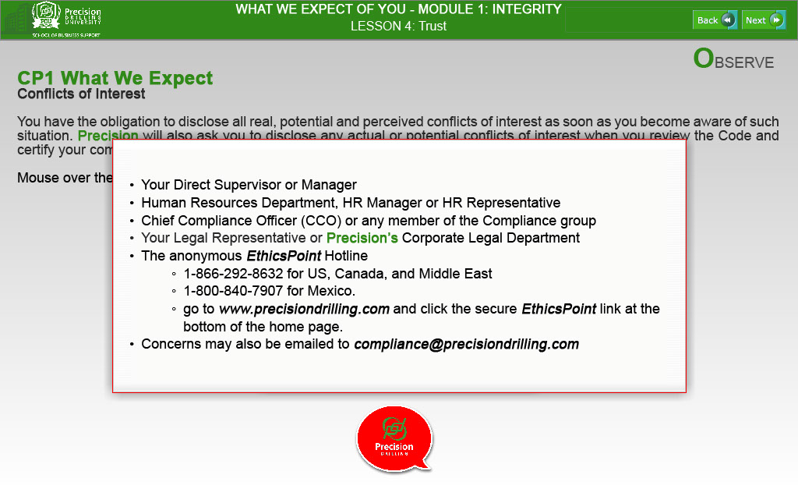
Text Captions
OBSERVE

CP1 What We Expect
Conflicts of Interest

You have the obligation to disclose all real, potential and perceived conflicts of interest as soon as you become aware of such situation. Precision will also ask you to disclose any actual or potential conflicts of interest when you review the Code and certify your compliance each year.

Mouse over the icon below for a list of ways to disclose and/or report Conflicts of Interest.

POPUP TEXT:
- Your Direct Supervisor or Manager
- Human Resources Department, HR Manager or HR Representative
- Chief Compliance Officer (CCO) or any member of the Compliance group
- Your Legal Representative or Precision’s Corporate Legal Department
- The anonymous EthicsPoint Hotline
- 1-866-292-8632 for US, Canada, and Middle East
- 1-800-840-7907 for Mexico.
- go to www.precisiondrilling.com and click the secure EthicsPoint link at the bottom of the home page.
- Concerns may also be emailed to compliance@precisiondrilling.com

Slide 11 - Slide 11
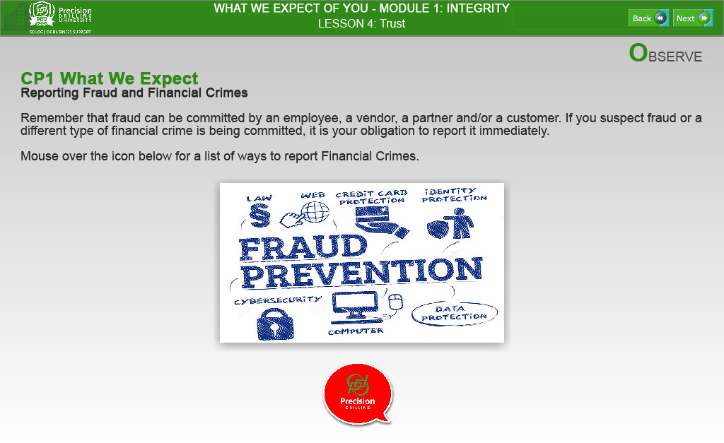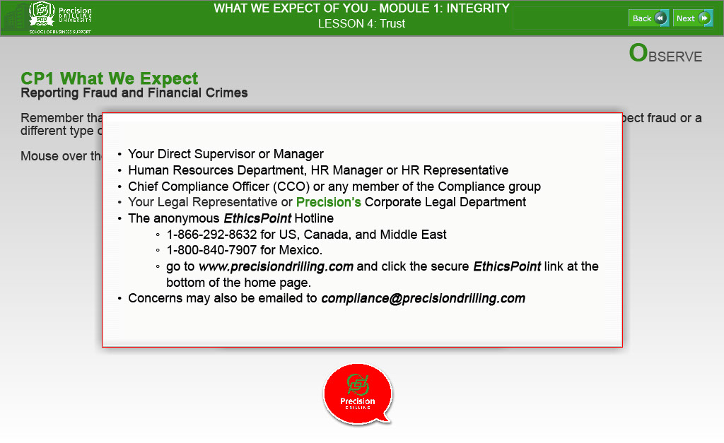
Text Captions
OBSERVE

CP1 What We Expect
Reporting Fraud and Financial Crimes

Remember that fraud can be committed by an employee, a vendor, a partner and/or a customer. If you suspect fraud or a different type of financial crime is being committed, it is your obligation to report it immediately.

Mouse over the icon below for a list of ways to report Financial Crimes.

POPUP TEXT:
- Your Direct Supervisor or Manager
- Human Resources Department, HR Manager or HR Representative
- Chief Compliance Officer (CCO) or any member of the Compliance group
- Your Legal Representative or Precision’s Corporate Legal Department
- The anonymous EthicsPoint Hotline
- 1-866-292-8632 for US, Canada, and Middle East
- 1-800-840-7907 for Mexico.
- go to www.precisiondrilling.com and click the secure EthicsPoint link at the bottom of the home page.
- Concerns may also be emailed to compliance@precisiondrilling.com

Slide 12 - Slide 12
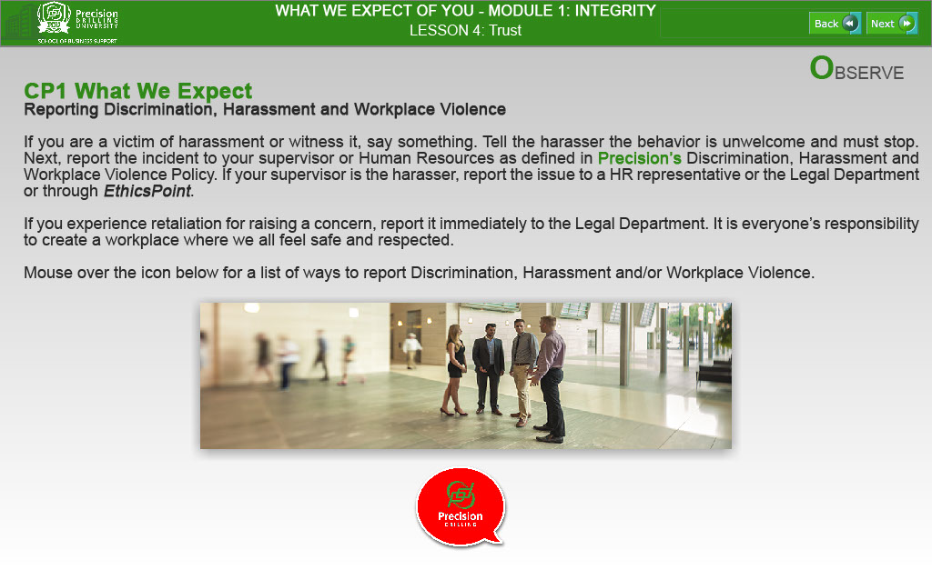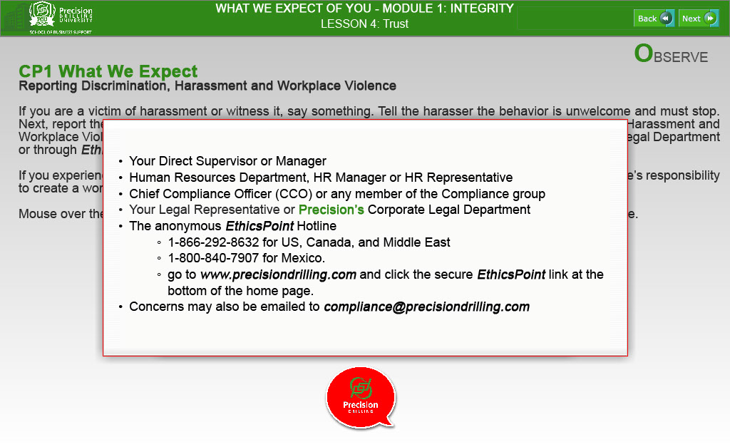
Text Captions
OBSERVE

CP1 What We Expect
Reporting Discrimination, Harassment and Workplace Violence

If you are a victim of harassment or witness it, say something. Tell the harasser the behavior is unwelcome and must stop. Next, report the incident to your supervisor or Human Resources as defined in Precision’s Discrimination, Harassment and Workplace Violence Policy. If your supervisor is the harasser, report the issue to a HR representative or the Legal Department or through EthicsPoint.

If you experience retaliation for raising a concern, report it immediately to the Legal Department. It is everyone’s responsibility to create a workplace where we all feel safe and respected.

Mouse over the icon below for a list of ways to report Discrimination, Harassment and/or Workplace Violence.

POPUP TEXT:
- Your Direct Supervisor or Manager
- Human Resources Department, HR Manager or HR Representative
- Chief Compliance Officer (CCO) or any member of the Compliance group
- Your Legal Representative or Precision’s Corporate Legal Department
- The anonymous EthicsPoint Hotline
- 1-866-292-8632 for US, Canada, and Middle East
- 1-800-840-7907 for Mexico.
- go to www.precisiondrilling.com and click the secure EthicsPoint link at the bottom of the home page.
- Concerns may also be emailed to compliance@precisiondrilling.com

Slide 13 - Slide 13
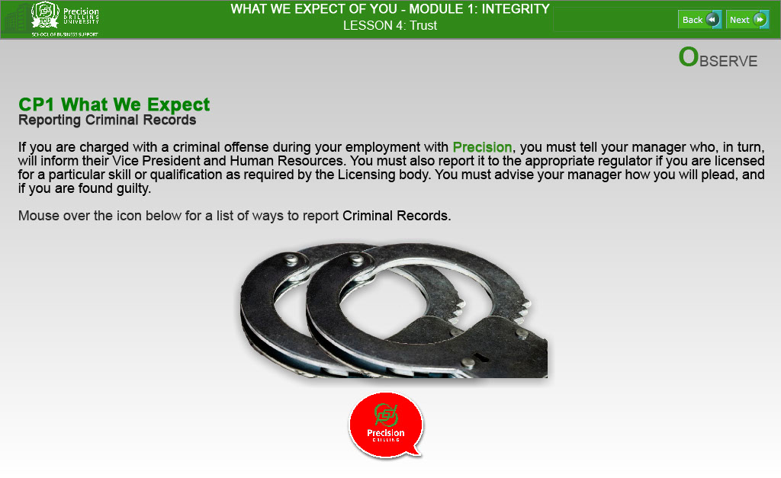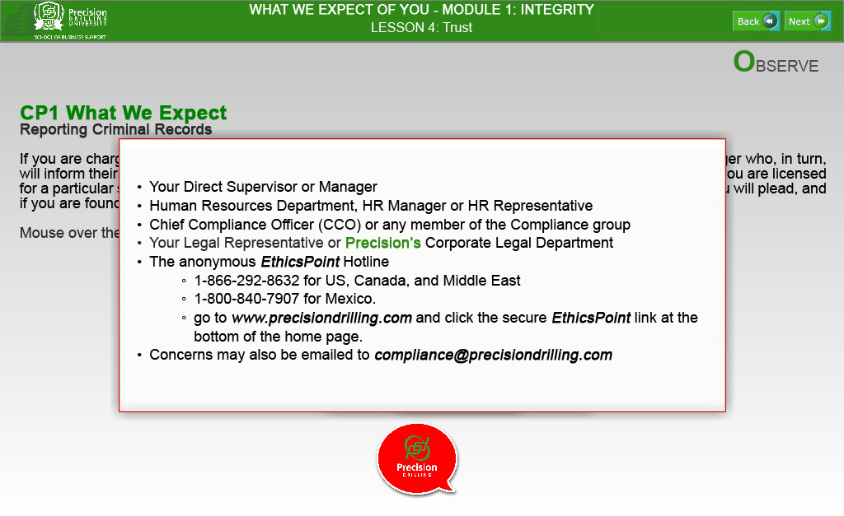
Text Captions
OBSERVE
WHAT WE EXPECT OF YOU - MODULE 1: INTEGRITY
CP1 What We Expect
Reporting Criminal Records

If you are charged with a criminal offense during your employment with Precision, you must tell your manager who, in turn, will inform their Vice President and Human Resources. You must also report it to the appropriate regulator if you are licensed for a particular skill or qualification as required by the Licensing body. You must advise your manager how you will plead, and if you are found guilty.

Mouse over the icon below for a list of ways to report Criminal Records.

POPUP TEXT:
- Your Direct Supervisor or Manager
- Human Resources Department, HR Manager or HR Representative
- Chief Compliance Officer (CCO) or any member of the Compliance group
- Your Legal Representative or Precision’s Corporate Legal Department
- The anonymous EthicsPoint Hotline
- 1-866-292-8632 for US, Canada, and Middle East
- 1-800-840-7907 for Mexico.
- go to www.precisiondrilling.com and click the secure EthicsPoint link at the bottom of the home page.
- Concerns may also be emailed to compliance@precisiondrilling.com

Slide 14 - Slide 14
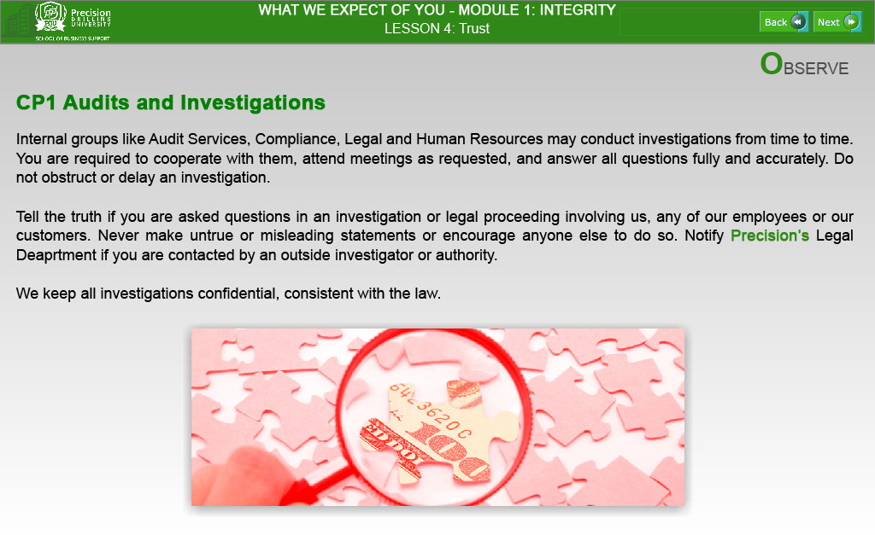
Text Captions
OBSERVE

CP1 Audits and Investigations

Internal groups like Audit Services, Compliance, Legal and Human Resources may conduct investigations from time to time. You are required to cooperate with them, attend meetings as requested, and answer all questions fully and accurately. Do not obstruct or delay an investigation.

Tell the truth if you are asked questions in an investigation or legal proceeding involving us, any of our employees or our customers. Never make untrue or misleading statements or encourage anyone else to do so. Notify Precision’s Legal Deaprtment if you are contacted by an outside investigator or authority.

We keep all investigations confidential, consistent with the law.

LESSON 4: Trust

Slide 15 - Slide 15
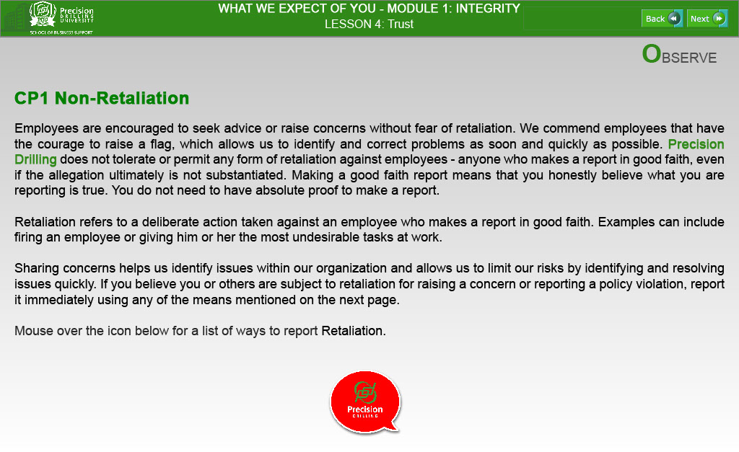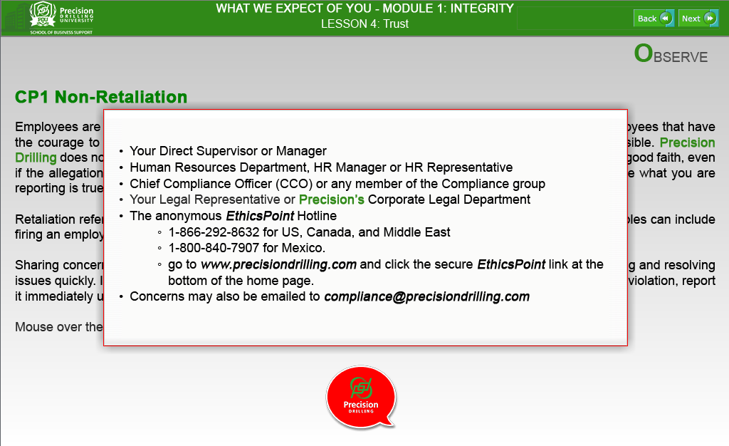
Text Captions
OBSERVE

CP1 Non-Retaliation

Employees are encouraged to seek advice or raise concerns without fear of retaliation. We commend employees that have the courage to raise a flag, which allows us to identify and correct problems as soon and quickly as possible. Precision Drilling does not tolerate or permit any form of retaliation against employees - anyone who makes a report in good faith, even if the allegation ultimately is not substantiated. Making a good faith report means that you honestly believe what you are reporting is true. You do not need to have absolute proof to make a report.

Retaliation refers to a deliberate action taken against an employee who makes a report in good faith. Examples can include firing an employee or giving him or her the most undesirable tasks at work.

Sharing concerns helps us identify issues within our organization and allows us to limit our risks by identifying and resolving issues quickly. If you believe you or others are subject to retaliation for raising a concern or reporting a policy violation, report it immediately using any of the means mentioned on the next page.

Mouse over the icon below for a list of ways to report Retaliation.

POPUP TEXT:
- Your Direct Supervisor or Manager
- Human Resources Department, HR Manager or HR Representative
- Chief Compliance Officer (CCO) or any member of the Compliance group
- Your Legal Representative or Precision’s Corporate Legal Department
- The anonymous EthicsPoint Hotline
- 1-866-292-8632 for US, Canada, and Middle East
- 1-800-840-7907 for Mexico.
- go to www.precisiondrilling.com and click the secure EthicsPoint link at the bottom of the home page.
- Concerns may also be emailed to compliance@precisiondrilling.com

Slide 16 - Slide 16
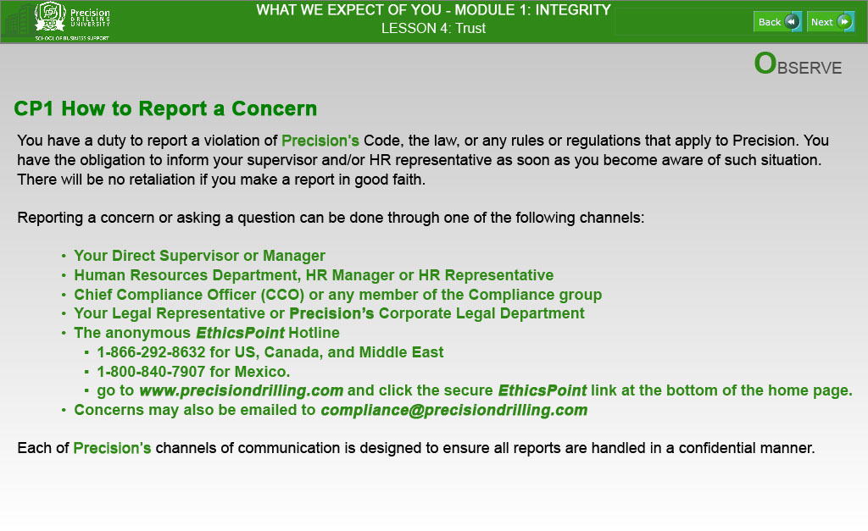
Text Captions
OBSERVE
CP1 How to Report a Concern

You have a duty to report a violation of Precision’s Code, the law, or any rules or regulations that apply to Precision. You have the obligation to inform your supervisor and/or HR representative as soon as you become aware of such situation. There will be no retaliation if you make a report in good faith.

Reporting a concern or asking a question can be done through one of the following channels:

- Your Direct Supervisor or Manager
- Human Resources Department, HR Manager or HR Representative
- Chief Compliance Officer (CCO) or any member of the Compliance group
- Your Legal Representative or Precision’s Corporate Legal Department
- The anonymous EthicsPoint Hotline
- 1-866-292-8632 for US, Canada, and Middle East
- 1-800-840-7907 for Mexico.
- go to www.precisiondrilling.com and click the secure EthicsPoint link at the bottom of the home page.
- Concerns may also be emailed to compliance@precisiondrilling.com

Each of Precision’s channels of communication is designed to ensure all reports are handled in a confidential manner.
Slide 17 - Slide 17

Text Captions
DEVELOP

In the next section of Lesson 4, you will further explore “Trust” through interactive Learning Activities.

When you are ready to begin this “Develop” Section, please click the “NEXT” button.

WHAT WE EXPECT OF YOU - MODULE 1: INTEGRITY

LESSON 4: Trust

Slide 18 - Slide 18
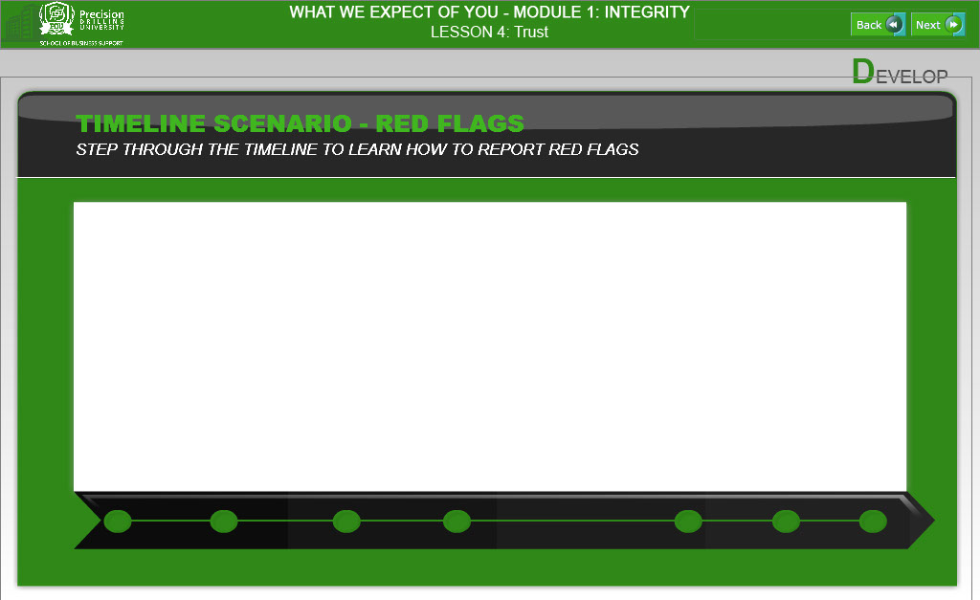

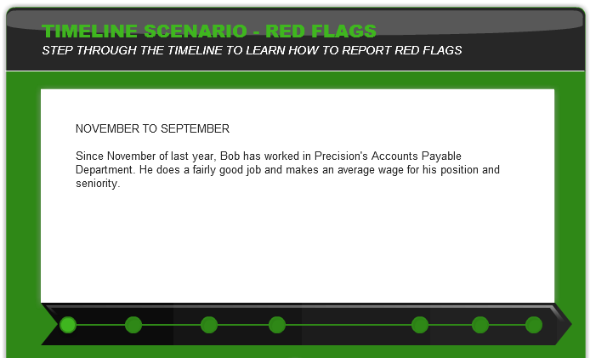
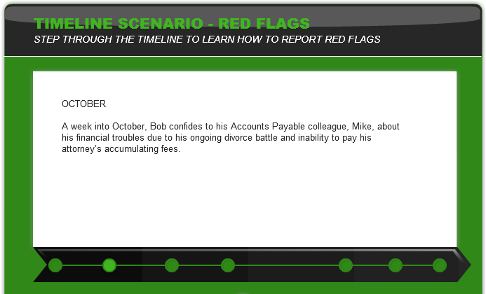

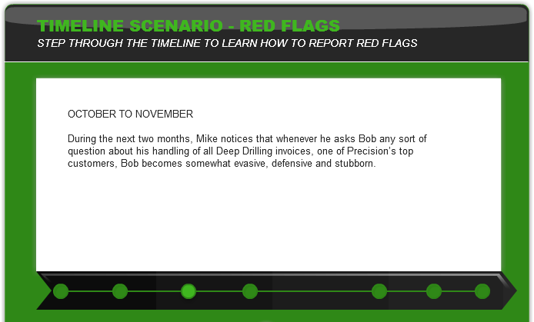
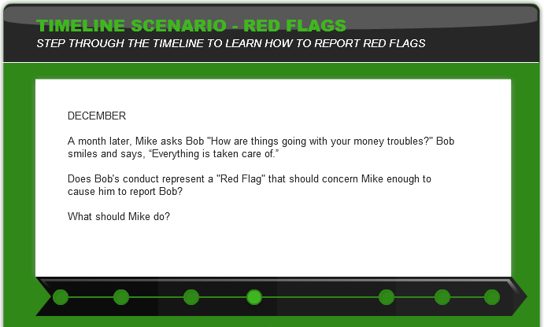

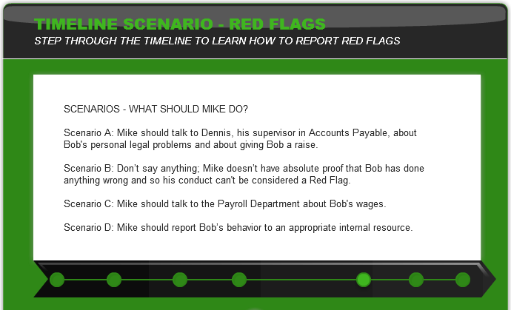
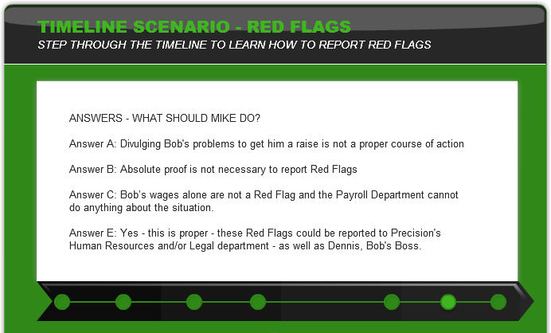

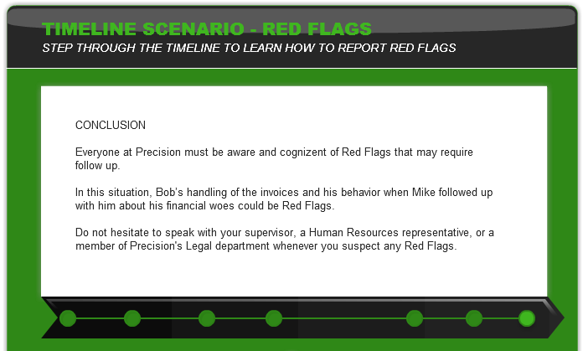

LESSON 4: Trust

WHAT WE EXPECT OF YOU - MODULE 1: INTEGRITY

Slide 19 - Slide 19
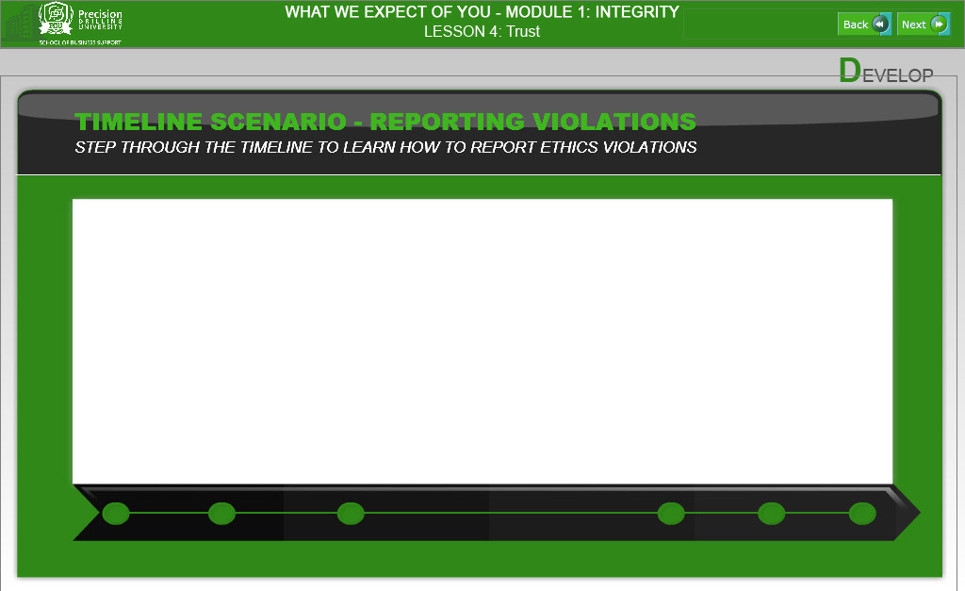

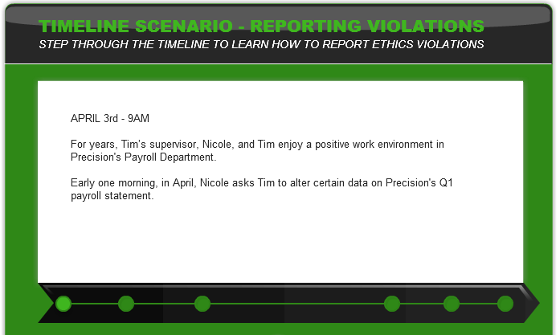
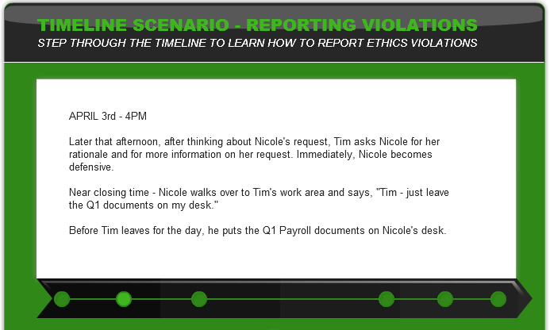

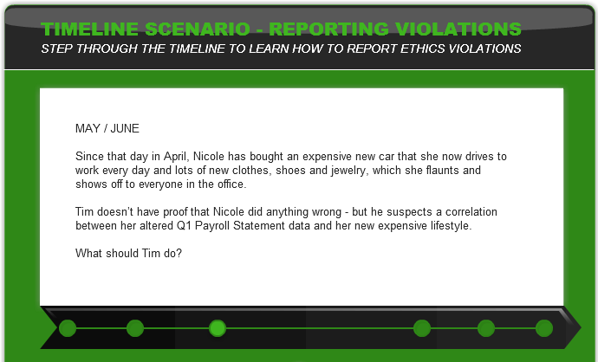
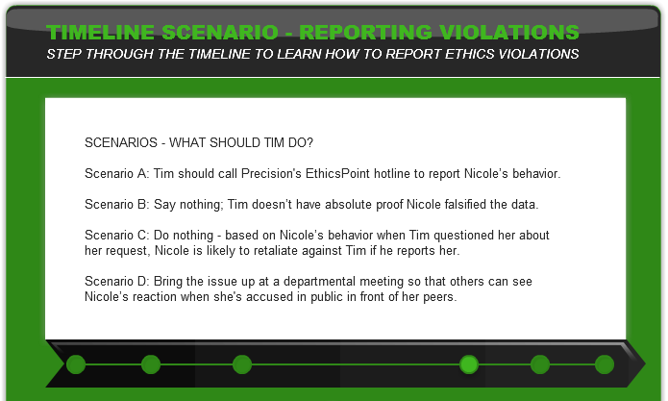

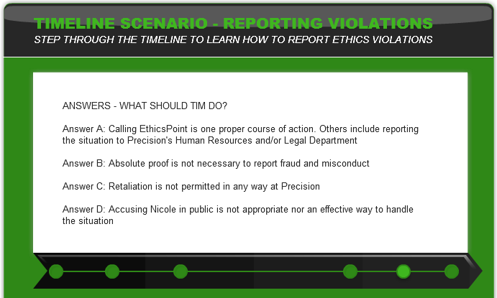
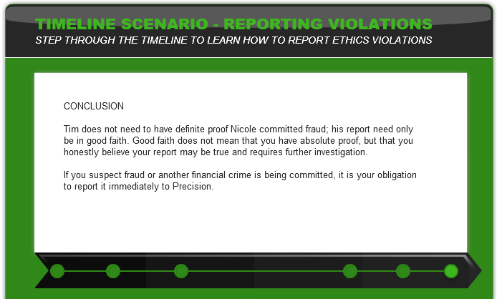
LESSON 4: Trust

WHAT WE EXPECT OF YOU - MODULE 1: INTEGRITY

Slide 20 - Slide 20
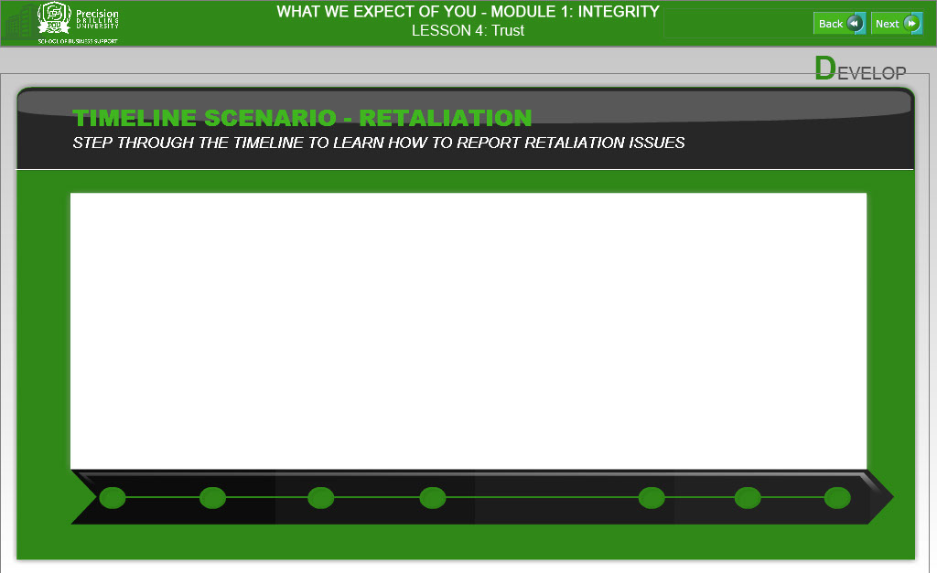

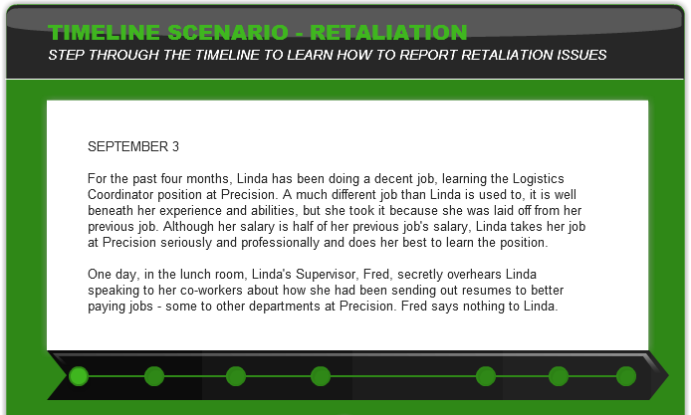
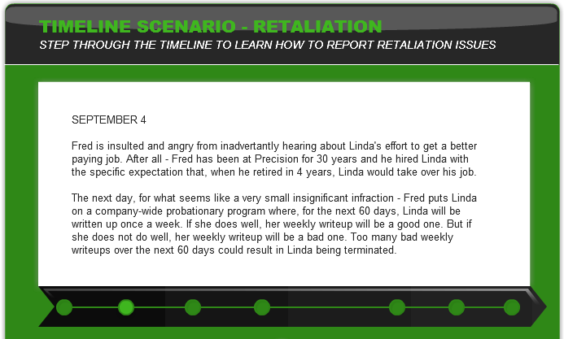

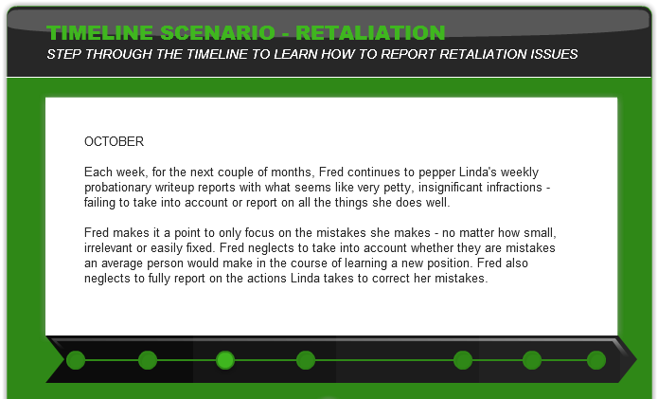
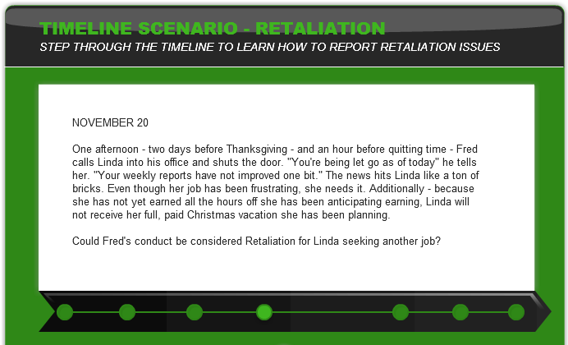

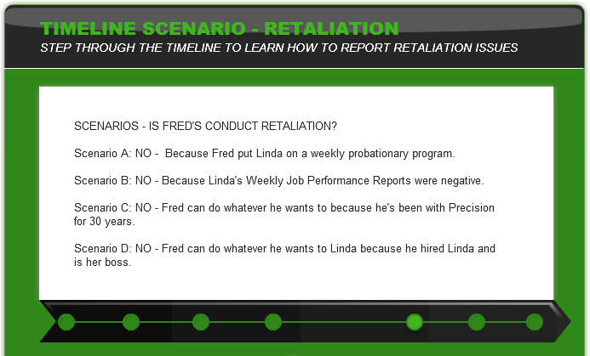
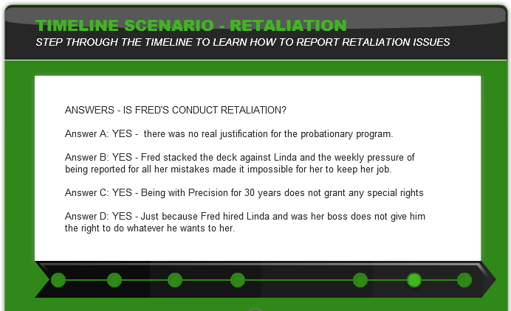

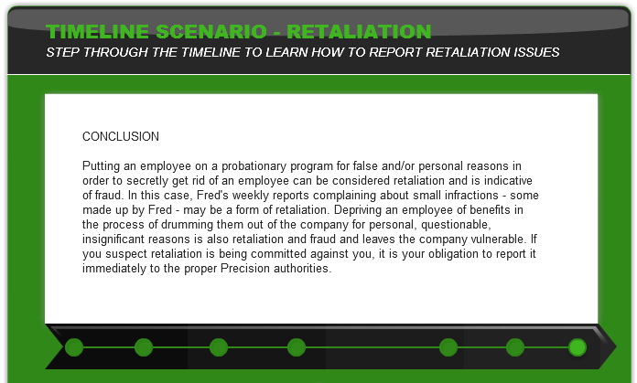

WHAT WE EXPECT OF YOU - MODULE 1: INTEGRITY

Slide 21 - Slide 21

Text Captions
EXAM
OF YOU - MODULE 1: INTEGRITY
In the final “Exam” section of Lesson 4, you will be asked some simple questions in the form of Knowledge Checks to showcase your mastery of Lesson 4 course material.

When you are ready to take this short, ungraded quiz, please click the “NEXT” button.

LESSON 4: Trust

Slide 22 - Slide 22
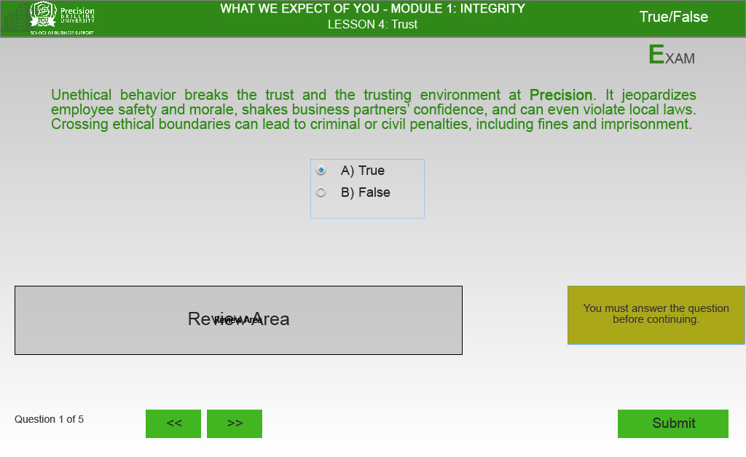
Text Captions
EXAM

Unethical behavior breaks the trust and the trusting environment at Precision. It jeopardizes employee safety and morale, shakes business partners’ confidence, and can even violate local laws. Crossing ethical boundaries can lead to criminal or civil penalties, including fines and imprisonment.

A) True
B) False

Question 1 of 5

Slide 23 - Slide 23
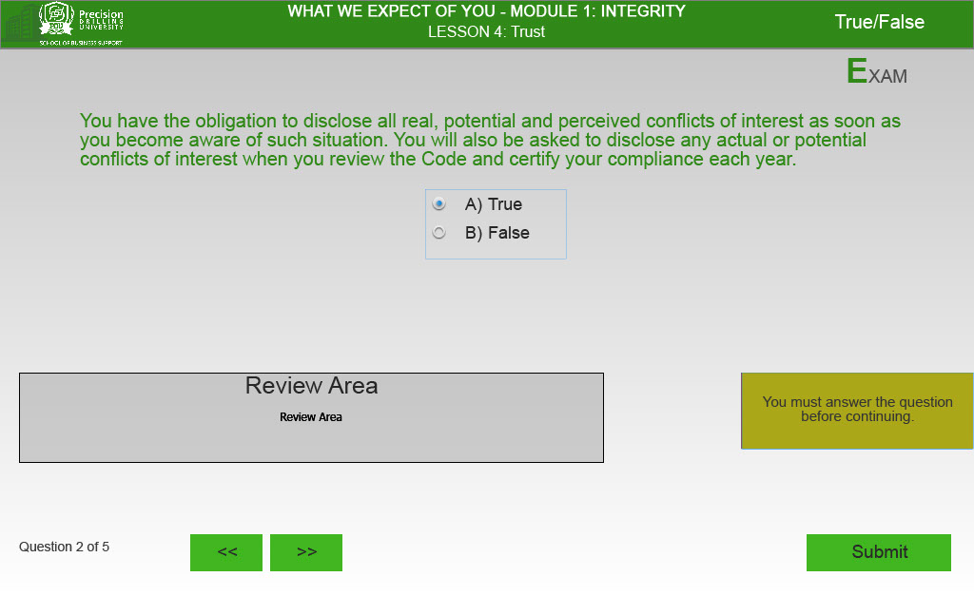
Text Captions
EXAM

You have the obligation to disclose all real, potential and perceived conflicts of interest as soon as you become aware of such situation. You will also be asked to disclose any actual or potential conflicts of interest when you review the Code and certify your compliance each year.

A) True
B) False

Question 2 of 5

Slide 24 - Slide 24
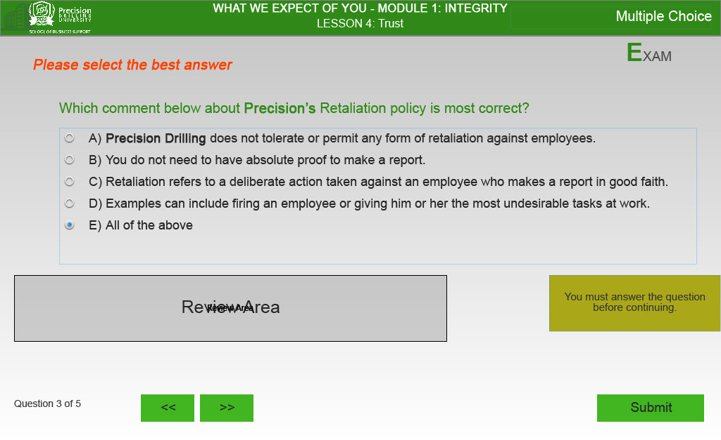
Text Captions
EXAM

Please select the best answer

Which comment below about Precision’s Retaliation policy is most correct?

A) Precision Drilling does not tolerate or permit any form of retaliation against employees.
B) You do not need to have absolute proof to make a report.
C) Retaliation refers to a deliberate action taken against an employee who makes a report in good faith.
D) Examples can include firing an employee or giving him or her the most undesirable tasks at work.
E) All of the above

Question 3 of 5

Slide 25 - Slide 25
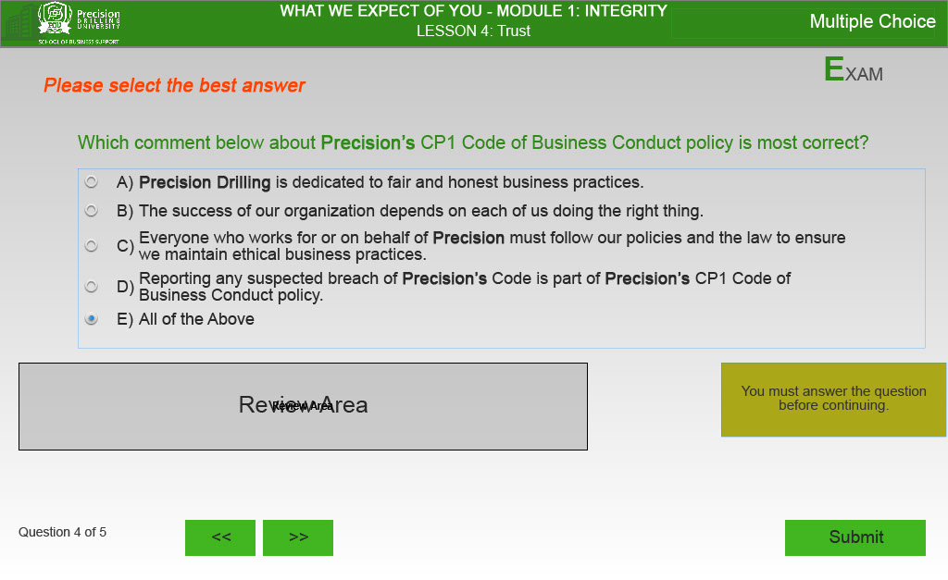
Text Captions
EXAM

Please select the best answer

Which comment below about Precision’s CP1 Code of Business Conduct policy is most correct?

A) Precision Drilling is dedicated to fair and honest business practices.
B) The success of our organization depends on each of us doing the right thing.
C) Everyone who works for or on behalf of Precision must follow our policies and the law to ensure we maintain ethical business practices.
D) Reporting any suspected breach of Precision’s Code is part of Precision’s CP1 Code of Business Conduct policy.
E) All of the Above

Question 4 of 5

Slide 26 - Slide 26
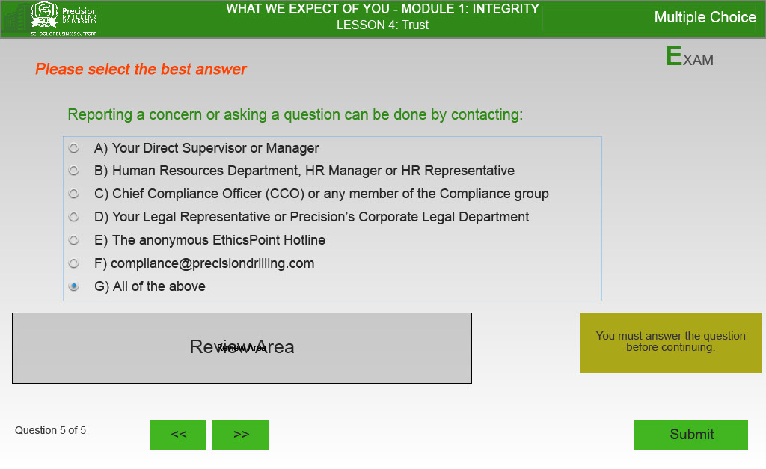
Text Captions
EXAM

Please select the best answer

Reporting a concern or asking a question can be done by contacting:

A) Your Direct Supervisor or Manager
B) Human Resources Department, HR Manager or HR Representative
C) Chief Compliance Officer (CCO) or any member of the Compliance group
D) Your Legal Representative or Precision’s Corporate Legal Department
E) The anonymous EthicsPoint Hotline
F) compliance@precisiondrilling.com
G) All of the above

Question 5 of 5

Slide 27 - Slide 27
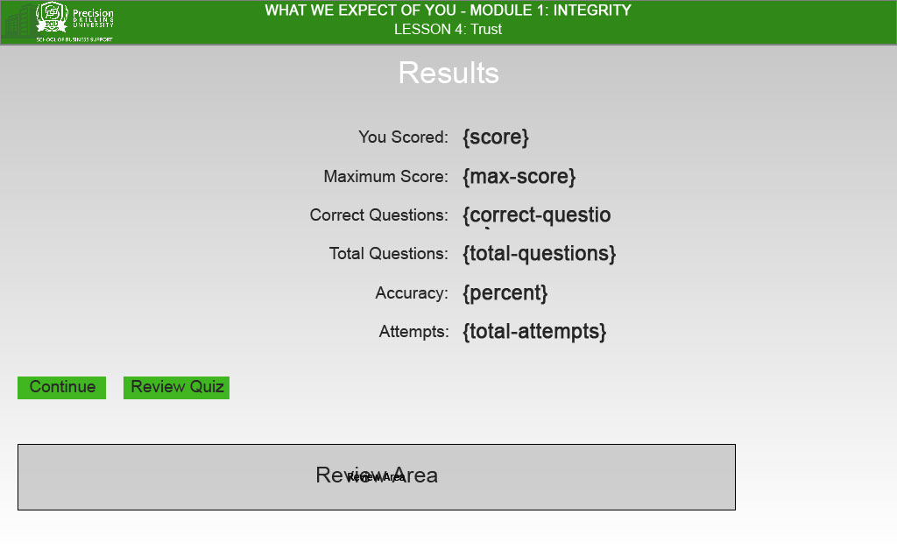
Slide 28 - Slide 28
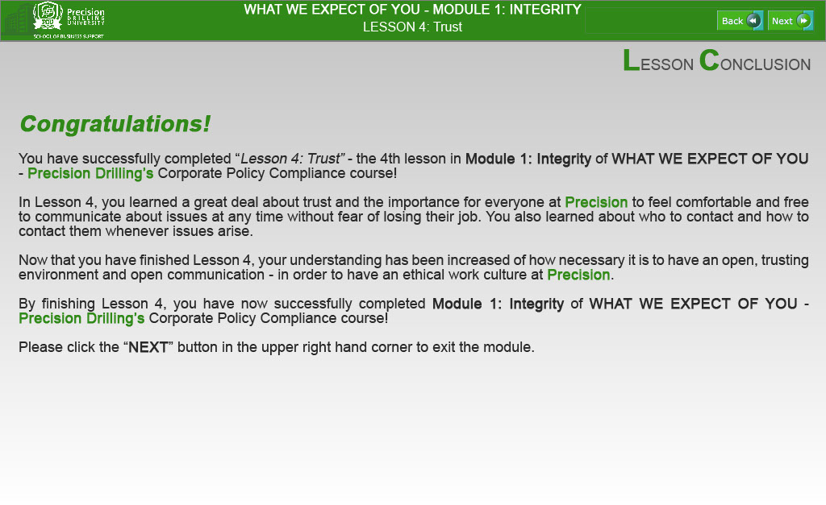
Text Captions
LESSON CONCLUSION

Congratulations!

You have successfully completed “Lesson 4: Trust” - the 4th lesson in Module 1: Integrity of WHAT WE EXPECT OF YOU - Precision Drilling’s Corporate Policy Compliance course!

In Lesson 4, you learned a great deal about trust and the importance for everyone at Precision to feel comfortable and free to communicate about issues at any time without fear of losing their job. You also learned about who to contact and how to contact them whenever issues arise.

Now that you have finished Lesson 4, your understanding has been increased of how necessary it is to have an open, trusting environment and open communication - in order to have an ethical work culture at Precision.

By finishing Lesson 4, you have now successfully completed Module 1: Integrity of WHAT WE EXPECT OF YOU - Precision Drilling’s Corporate Policy Compliance course!

Please click the “NEXT” button in the upper right hand corner to exit the module.

